

**DEPARTMENT OF COMPUTER SCIENCE AND ENGINEERING**

**V SEMESTER**

**CSP63 WEB TECHNOLOGY LABORATORY**

**LAB MANUAL**

|  |  |  |  |  |
| --- | --- | --- | --- | --- |
| **Subject**  **Code** | **Subject Name** | **Lectures**  **(Periods)** | **Tutorial**  **(Periods)** | **Practical**  **(Periods)** |
| **CS P63** | **WEB TECHNOLOGY LABORATORY** | - | - | 3 |
| **LIST OF EXPERIMENTS**   1. Creation of HTMLFiles 2. Working with Client SideScripting    1. VBScript    2. JavaScript 3. Configuration of webservers    1. Apache WebServer    2. Internet Information Server (IIS) 4. Working with ActiveX Controls in webdocuments. 5. Experiments in Java ServerPages    1. Implementing MVC Architecture usingServlets    2. Data Access Programming (usingADO)    3. Session and Applicationobjects    4. File SystemManagement 6. Working with other Server SideScripting    1. Active ServerPages    2. JavaServlets    3. PHP 7. Developing Web Applications usingXML. 8. Experiments in AjaxProgramming 9. Developing WebServices 10. Developing any E-commerce application (MiniProject) | | | | |

**EX NO: 1 STUDY OF HTML**

**AIM:**

To study about the basic **HTML** tags.

**HTML:**

**H**yper **T**ext **M**arkup **L**anguage is how a web browser displays its multimedia documents. The documents themselves are plain text files (ASCII) with special **"**tags**”** or codes that a browser knows how to interpret and display on your screen.

**HTML Tags :**

**a) Basics Tags:-**

**i.<html></html>**

The basic tag for every page. This tells the browser that the file being loaded is a HTML document.

**ii.<head></head>**

Head - defines the head of your page. Includes the **<title></title>** tag.

**iii. <title></title>**

Title - allows you to display a title at the top of the browser.

**iv. <Meta>**

Meta Tags - allows the owner to display certain information to the browser without the page seeing it. Here are some examples:  
**<meta name="description" content="This is my page description.">**- describe your page  
**<meta name="keywords" content="word1, word2, word3, word4">** - enter keywords for your page.  
**<meta HTTP-EQUIV="refresh" content="10; url=index2.html">** - reloads the page after 10 seconds to index2.html  
**<meta HTTP-EQUIV="text" content="This is my page description.">** - another text tag

**v. <body></body>**

Allows you to define the body arguments. This can include:

* background="file.gif"
* bgcolor="#rgbcode"
* te-xt="#rgbcode"
* link="#rgbcode"
* vlink="#rgbcode"
* topmargin=*n* - defines the top of the margin for the body.
* leftmargin=*n*
* rightmargin=*n*

**b) Text Control and Tags:-**

**i. <h1></h1>**

Header - this allows you to change the size of the letter or words it's surrounding. Covers H1 - H6, H1 being the biggest and H6 being the smallest.

**ii. <center></center>**

Center - allows you to display the text in the center of the page.

**iii. <ins></ins>**

Inserted Text - allows you to insert text.

**iv. <person></person>**

Person's Name - allows you to distinguish someone's name, like Shpank.

**v. <q></q>**

Quotation - set certain test as a quote.

**vi. <big></big><small></small>**

Big - makes the test bigger than the rest.

Small - makes the text smaller than the rest.

**vii.<sub></sub>**

Subscript - allows you to make the text look like this.

**viii. <sup></sup>**

Superscript - gives superscript effect to your text.

**ix. <abbrev></abbrev>**

Abbreviation - abbreviate certain text.

**x.<del></del>**

Deleted Text

**xi. <font></font>**

Font - allows you to control different aspects of the text.

**Includes:** -  
size=*n* (+1 - +5) (-1 - -5)   
color=*#rgbcode* - defines the color  
face=*"name"* - defines the font face. Could be Helvetica, Arial, etc.

**xii. <b></b>**

Bold - makes a word or group of words **bold**. <b&gtbold</b>.

**xiii. <strong></strong>**

Strong - basically the same as **bold**, just longer code. <strong&gtbold</strong>

**xiv. <i></i>**

Italics - italicizes a word or *group of words*.

**xv. <em></em>**

Emphasis - basically the same as italics.

**xvi. <u></u>**

Underline - underlines a word or group of words. But does not work with all browsers.

**xvii. <tt></tt>**

Typewriter Type - makes a fixed width font.

**xviii. <address></address>**

Address – another italics tag

**xix. <blockquote></blockquote>**

Block Quote - indents the left and right-hand sides of the text.

**xx. <dfn></dfn>**

Definition - allows emboldening or italicizing a word or group of words.

**xxii. <kbd></kbd>**

Keyboard - another fixed width font.

**xxiii. <var></var>**

Italics - another way to italics word or group of words.

**xxiv. <pre></pre>**

Preformatted - allows the text to appear in the browser as it does on the page.

**Lists:-**

**<dl></dl>**

Descriptive List - another way to list things.

**<dt></dt>**

Defines the topic of the descriptive list.

**<dd></dd>**

The Descriptive Description. This indented part that is displayed.

**<ol></ol>**

Ordered List - a way to group items into a list.

**<li></li>**

Line item tag defines the list items with a number or a dot. Includes the following:

* start=*n*
* type="A/a/I/i" for upper or lower case and Roman numerals.

**<ul></ul>**

Unordered List - another way to list items. Also uses the <li></li> tags to define the list items with a bullet instead of a number. Includes the following options:

* type="DISC/CIRCLE/SQUARE"

**Page Breaks and Lines :-**

**<hr>**

Horizontal Rule - allows you to divide a page with a line. Includes the following options:

* width=pixels/percentage
* align=left/right/center
* size=*n* noshade - takes away the shading inside.

**<br>**

Break - allows the text to break without a full paragraph. The options are:

* clear=left/right/all

**<nobr></nobr>**

No Breaks - allows the test to continue without breaking.

**Frames, Tables, and Forms :-**

**<table></table>**

Tables - these tags allow you to insert tables into your page like all of mine. It has the following options:

* width=*n*
* height=*n*
* border=*n*
* cellpadding=*n*
* cellspacing=*n*

It also includes the following tags with their associated options:

* <tr></tr>
* <td></td>
* <th></th>
* align=left/middle/right
* valign=top/middle/bottom
* color=#rgbcode
* colspan=*n*
* rowspan=*n*

**<frameset></frameset>**

Frameset - allows you to setup frames on your page. Includes the following:

* rows="pixels/percentage"
* cols="pixels/percentage"
* frameborder=*n*
* framewidth=*n*
* marginheight=*n*
* marginwidth=*n*

Also includes the frame tag to establish content. These include:

* marginheight=*n*
* marginwidth=*n*
* name="name"
* noresize
* src="file.html/file.gif/file.jpg"
* scrolling="yes/no/auto"

The **<noframes>** tag for those browsers who can't handle frames or they won't get bunk.

**<frame>**

Frame - includes the frame tag to establish content. These include:

* marginheight=*n*
* marginwidth=*n*
* name="name"
* noresize
* src="file.html/file.gif/file.jpg"
* scrolling="yes/no/auto"

**<form></form>**

Form - this allows you to insert forms onto your page. It includes the following options:

* method=POST/GET
* action="file/script

Also, you can use the following to add checkbox's, text box's, and more. They include:

* <input type="text/hidden/checkbox/radio/submit/reset size="*n*" maxlength="*n*" name="name" value="file/URL">
* <select name="name" size="*n*">
* <option value="value1"&gtValue1</option>

**<multicol></multicol>**

Multicolumns - allows almost the same effect as tables. It has the following options:

1. cols="*n*"
2. gutter="*n*"
3. width="pixels/percentage"

**Images and Links:-**

**<a href="file"></a>**

Hypertext Anchor - this allows you to make certain text or picture a link to another page or graphic not on the page. It can include the following options:

* target="frame name"

**<img>**

Image - this allows you to insert a .jpg or .gif image into your web page. It has the following options:

* src="file.gif"/src="file.jpg"
* height=*n*
* width=*n*
* lowsrc="file.gif"/lowsrc="file.jpg"
* alt="text"
* usemap="#mapname"
* ismap
* align="left/right/middle/bottom/top/absmiddle/textop/absbottom"
* border=*n*

**<map></map>**

Image Map - used to define the areas and coordinates of an image map.

**Applets, JavaScript, and Other Tags :-**

**<applet></applet>**

Java Applet - allows you to insert a Java applet directly into your page. It includes:

* code="java.class"
* codebase="/dir/to/applet"
* height="*n*"
* width="*n*"

**<script></script>**

Javascript - allows a JavaScript to load within the page. This tag usually appears after the </title> and before the </head> tag.

<title>Title</title>  
<script language="JavaScript">  
Script goes here.  
</script>  
</head>

**<!-- text -->**

Allows text to appear invisible on the page. This is used if you would like to save comments on the page, but not have them load on the page.

**<marquee></marquee>**

Marquee - an IE only tag, so only IE users will see it. It allows scrolling text in the browser. Includes:

* behavior=slide/alternative
* width=pixels/percentage
* hspace=*n*
* vspave=*n*
* loop=n/-1/infinite
* bgcolor=#rgbcode
* scrollamount=*n*
* scrolldelay=*n*

**RESULT:**

Thus the basic **HTML** tags were studied.

**2. CREATE YOUR OWN WEB PAGE**

**Aim:**

To create a web page using HTML.

**Algorithm:**

1. initialize the web page using **HTML** tag.
2. Insert the heading of the page.
3. The body of the page contains the details about the web page.
4. Save the file using “.html” extension.

**Program:**

<html>

<head>

<title> My Page </title>

</head>

<body bgcolor="white" text="green" link="blue">

<font color="green" size=13 face="Times New Romen">

<h1 align="center"> Sri </font>

<font color="blue" size=13 face="Times New Romen">Venkateshwaraa </h1></font>

<h2 align="center"><font color="green" size=13 face="Times New Romen" >

College of Engineering & Technology</h2>

</font>

<br>

<font color="black" size=4 face="Times New Romen">

<h2 align="left"> Department</h2>

</font>

<font color="red" size=4 face="Times New Romen">

<ul>

<a href='cse.html'><i><li><b>C</b>omputer <b>S</b>cience <b>E</b>ngineering</a>

<a href='ce.html'><i><li><b>C</b>ivil <b>E</b>ngineering</a>

<a href='me.html'><li><b>M</b>echanical <b>E</b>ngineering</a>

<a href='eee.html'><li><b>E</b>lectrical &<b>E</b>lectronic <b>E</b>ngineering</a>

<a href='ecehtml'><li><b>E</b>lectronic &<b>C</b>ommunication <b>E</b>ngineering</a>

</i>

</ul>

<font color="black" size=4 face="times new roman">

<h2 align="left"><b>Extra Activity</b></h2>

</font>

<ul>

<i><li><b>P</b>project <b>E</b>xpo & <b>C</b>ulturals

<li><b>S</b>ports

<li><b>I</b>ndustrial visit

<li><b>Y</b>oga

</i>

</ul>

</font>

<br>

<br>

<marquee>Welcome to our college webpage......</marquee>

</body>

</html>

**OUTPUT**

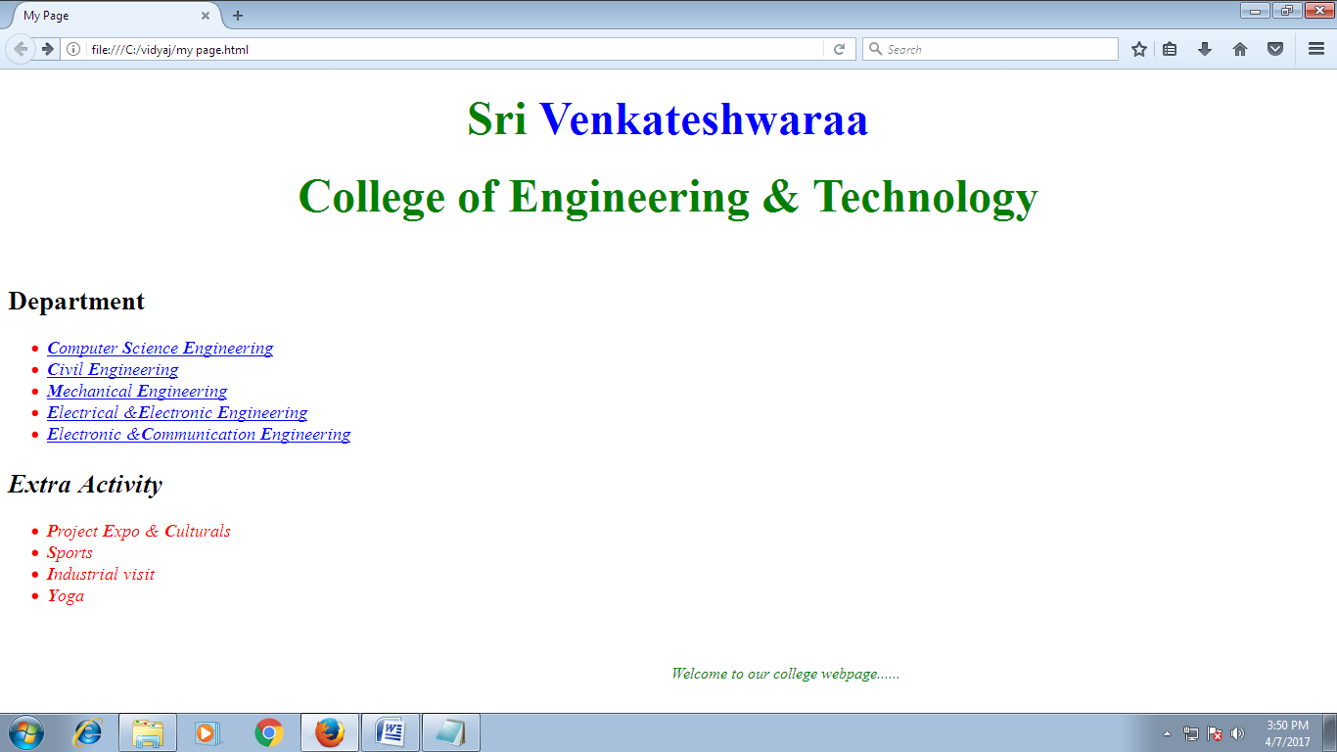

**Result:**

Thus the web page has been created using HTML.

3.**CREATION OF HTML FILES-IMAGE MAPPING**

**Aim:**

To create a web page which includes a map and display the related information when a hot spot is clicked in the map.

**Algorithm:**

Step 1: Create a html file with map tag.

Step 2: Set the source attribute of the img tag to the location of the image and also set the usemap attribute.

Step 3: Specify an area with name, shape and set the coordinate points to the appropriate values.

Step 4: Repeat step 3 as many hot spots you want to put in the map.

Step 5: Create html files for each and every hot spots the user will select.

**Program:**

**Home.html**

<html>

<head>

<title>Image Map</title>

</head>

<body>

<MAP id="picture">

<AREA href="Tamil Nadu.html" shape="circle" coords="300,900,30" alt="Tamilnadu" />

<AREA href="Karnataka.html" shape="circle" coords="250,800,35" alt="Karnataka" />

<AREA href="Andhra Pradesh.html" shape="circle" coords="350,700,40" alt="AndhraPradesh" />

<AREA href="Kerala.html" shape="circle" coords="260,940,20" alt="Kerala" />

</MAP>

<img src="India-Map.jpg" alt="india1" usemap="#picture" />

</body>

</html>

**Tamil Nadu.html**

<html>

<head>

<title> About Tamil Nadu</title>

</head>

<body>

<center><h1> Tamil Nadu </h1></center>

<hr>

<ul>

<li> AREA : 1,30,058 Sq.Kms </li>

<li> Capital : Chennai </li>

<li> Language : Tamil </li>

<li> Population: 6,21,10,839 </li>

</ul>

<hr>

<a href='Home.html'>India Map</a>

</body>

</html>

**Kerala.html**

<html>

<head>

<title> About Kerala</title>

</head>

<body>

<center><h1> Kerala </h1></center>

<hr>

<ul>

<li> AREA : 38,863 Sq.Kms </li>

<li> Capital : Thiruvananthapuram </li>

<li> Language : Malayalam </li>

<li> Population: 3,18,38,619 </li>

</ul>

<hr>

<a href='Home.html'>India Map</a>

</body>

</html>

**Karnataka.html**

<html>

<head>

<title> About Karanataka</title>

</head>

<body>

<center><h1> Karnataka </h1></center>

<hr>

<ul>

<li> AREA : 1,91,791 Sq.Kms </li>

<li> Capital : Bangalore </li>

<li> Language : Kannada </li>

<li> Population: 5,27,33,958 </li>

</ul>

<hr>

<a href='Home.html'>India Map</a>

</body>

</html>

**Andhra Pradesh.html**

<html>

<head>

<title> About Andhra Pradesh</title>

</head>

<body>

<center><h1> Andhra Pradesh </h1></center>

<hr>

<ul>

<li> AREA : 2,75,068 Sq.Kms </li>

<li> Capital : Hyderabad </li>

<li> Language : Telugu </li>

<li> Population: 7,57,27,541 </li>

</ul>

<hr>

<a href='Home.html'>India Map</a>

</body>

</html>

**Output:**

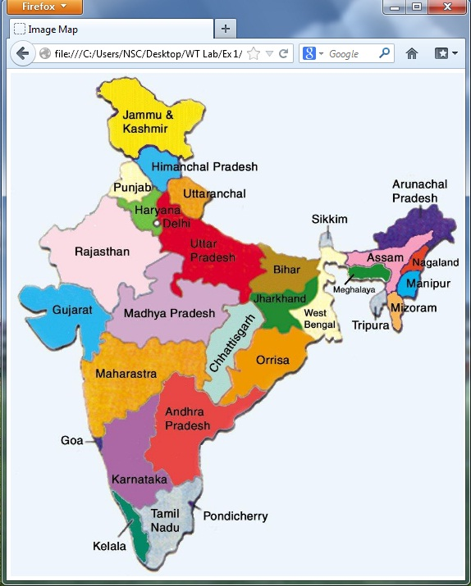

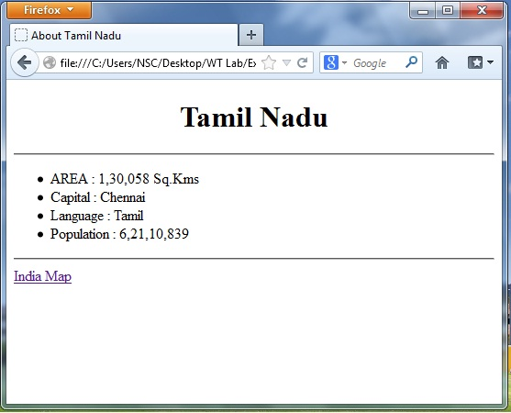

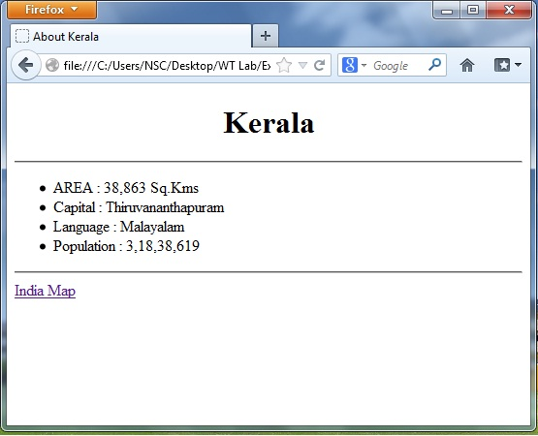

**Result:**

Thus the HTML program for mapping the image has been executed and the output is verified successfully.

**Ex No :4 CASCADING STYLE SHEETS**

**Aim:**

To create a web page that displays college information using various style sheets.

**Algorithm:**

Step 1: Create a web page with frame sets consisting two frames.

Step 2: In the first frame include the links.

Step 3: In the second frame set display the web page of the link.

Step 4: Create a external style sheets.

Step 5: Create a inline and internal style sheets and make it link to the external style sheets.

**Program**:

**Home.css**

h3{font-family:arial;font-size:20;color:red}

table{border-color:green}

td{font-size:20pt;color:magenta}

**Style Sheet.html**

<html>

<head>

<h1><center>ALL STYLE SHEETS</center></h1>

<title>USE of INTERNAL and EXTERNAL STYLESHEETS

</title>

<link rel="stylesheet" href="Home.css" type="text/css">

<style type="text/css">

.vid{font-family:verdana;font-style:italic;color:red;text-align:center}

.ani{font-family:tahoma;font-style:italic;font-size:20;text-align:left}

font{font-family:georgia;color:blue;font-size:20}

ul{list-style-type:circle}

</style>

</head>

<body>

<ol style="list-style-type:upper-alpha">

<b><h2><center>Ramachandra Educational Trusts</h2></center></b><br>

<li>Srivenkateswaraa College of Engineering & Technology

<li>Srivenkateswaraa Medical College Hospital and Research Institute

<li> Srivenkateswaraa Dental Coolege

<li>

</ol>

<p style="font-size:20pt;color:green"> Ramachandra Educational Trusts </p>

<p class="ani"> Ramachandra Educational Trusts is owned by Mr.B.Ramachandiran, Chairmanr.<br>

<h2 class="vid">Srivenkateswaraa College of Engineering & Technology</h2>

<font>

<p class="ani">It is approved by AICTE (All India Council for Technical Education).

It is affliated to Pondicherry University, Chennai.<br></p>

<font>

<h3>List of Courses offered</h3>

<ul>

<li><a href=’cse.html’>B.Tech - CSE</a></li>

<li> B.Tech - CIVIL</li>

<li> B.Tech - ECE</li>

<li> B.Tech - MECH</li>

<li> B.Tech - EEE</li>

<

</ul>

</font>

</body>

</html>

**cse.html**

<html>

<head><h1><center>ALL STYLE SHEETS</center></h1>

<title>Dept of IT</title>

<link rel="stylesheet" href="Home.css" type="text/css">

</head>

<body>

<p style="font-size:20pt;color:green;text-align:center">Department of Information Technology</p>

<h3><center>University Results</center></h3>

<table width="100%" cellspacing="2" cellpadding="2" border="5">

<tr>

<th>STUDENT NAME</th>

<th>MARKS</th>

<th>RESULT</th>

</tr>

<tr>

<td align="center">Mani</td>

<td align="center">100</td>

<td align="center">Pass</td>

</tr>

<tr>

<td align="center">Krishna</td>

<td align="center">92</td>

<td align="center">Pass</td>

</tr>

<tr>

<td align="center">Selvam</td>

<td align="center">88</td>

<td align="center">Pass</td>

</tr>

</table>

<br>

<a href='Style Sheet.html'>Home Page</a>

</body>

</html>

**Output:**

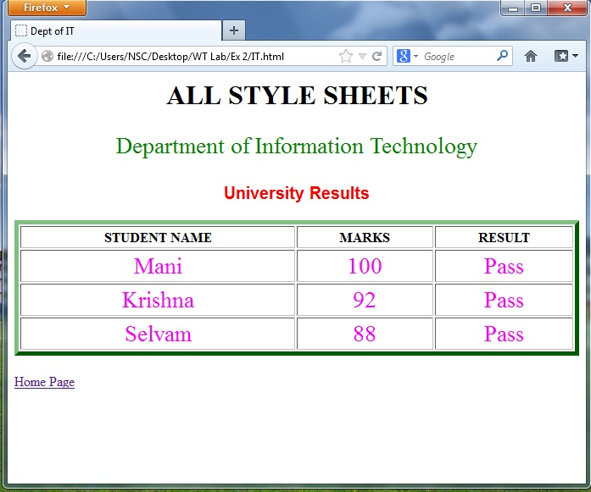

**Result:**

Thus the program for cascading style sheets has been executed and the output is verified successfully.

**Ex.No:5 WORKING WITH CLIENT SIDE SCRIPTING – JAVASCRIPT**

**Aim:**

To create a Client Side Scripts for Validating Web Form Controls using javascript.

**Algorithm:**

Step-1: Create a html file using notepad.

Step-2: Write a code to display the user details like Name, Password and Email.

Step-3: Create another html file using notepad.

Step-4: On submission of user details this html file should open.

Step-5: On clicking the reset button all the text boxes should be erased.

Step-6: Stop the program.

**Program:**

<html>

<head>

<title>Students Registration Form</title>

<script type="text/javascript">

function validate()

{

if(document.signup.fname.value=="")

{

alert("Please Enter First Name!");

return false;

}

if(document.signup.lname.value=="")

{

alert("Please Enter Last Name!");

return false;

}

if(document.signup.uname.value=="")

{

alert("Please Enter User Name!");

return false;

}

if(document.signup.pword1.value=="")

{

alert("Please Enter Password!");

return false;

}

if(document.signup.pword1.value<6)

{

alert("Please Enter min 6 characters!");

return false;

}

if(document.signup.pword2.value=="")

{

alert("Please Enter Password Again!");

return false;

}

if(document.signup.pword2.value!=document.signup.pword1.value)

{

alert("Password Mismatch Reenter Password!");

return false;

}

alert("Details Entered Successfully");

display();

}

function display()

{

document.writeln('<h2>'+"Details Entered:"+'</h2>');

document.writeln('<br/><font color="#0066ff">'+"First Name:"+'</font>'+document.signup.fname.value);

document.writeln('<br/><font color="#0066ff">'+"Last Name:"+'</font>'+document.signup.lname.value);

document.writeln('<br/><font color="#0066ff">'+"User Name:"+'</font>'+document.signup.uname.value);

document.writeln('<br/><font color="#0066ff">'+"Country:"+'</font>'+document.signup.country.value);

document.writeln('<br/><font color="#0066ff">'+"Alternate Email"+'</font>'+document.signup.aemail.value);

}

</script>

</head>

<body align="center" bgcolor="green">

<table width="100%" height="100%">

<td colspan="2" width="15%">

</td>

<td colspan="1" bgcolor="#ffffff" width="70%" height="100%">

<h1 align="center"><font color="#0066ff">S-Mail</font></h1>

<h2 align="center"><font color="#0066ff">New User Sign-Up Form</font></h2>

<form name="signup" onsubmit="return validate()">

<font face="verdana,arial,helvetica,sanserif" color="#660000" size="2">

<p>&nbsp;&nbsp;*First Name:<input type="text" name="fname" size="20">

&nbsp;&nbsp;*Last Name:<input type="text" name="lname" size="20"></p>

<p style="border">&nbsp;&nbsp;*User Name:<input type="text" name="uname" size="20">@smail.com</p>

<p style="border">&nbsp;&nbsp;*Password:<input type="password" name="pword1" size="20"></p>

<p style="border">&nbsp;&nbsp;*Confirm Password:<input type="password" name="pword2" size="20"></p>

<p>&nbsp;&nbsp;Gender:<input type="radio" name="gen"value="male">Male<input type="radio" name="gen" value="female">Female</p>

<p>&nbsp;&nbsp;Country:<select name="country">

<option selected>Select Country</option>

<option name="country" value="India">India</option>

<option name="country" value="Russia">Russia</option>

<option name="country" value="France">France</option>

<option name="country" value="Italy">Italy</option>

</select>

</p>

<p>&nbsp;&nbsp;Language Known:<br>

&nbsp;&nbsp;<input type="checkbox" name="lang" value="English">English<br>

&nbsp;&nbsp;<input type="checkbox" name="lang" value="Tamil">Tamil<br>

&nbsp;&nbsp;<input type="checkbox" name="lang" value="Hindi">Hindi<br>

&nbsp;&nbsp;<input type="checkbox" name="lang" value="Malayalam">Malayalam<br>

</p>

<p style="border">&nbsp;&nbsp;Alternate Email:<input type="text" name="aemail" size="20"></p>

<p align="center"><input type="checkbox" name="agree">I Agree The Terms & Conditions</p>

<p align="center"><input type="submit" value="submit">

<input type="reset" value="reset"></p>

</font>

</form>

</td>

<td colspan="2" width="15%">

</td>

</table>

</body>

</html>

**Output:**

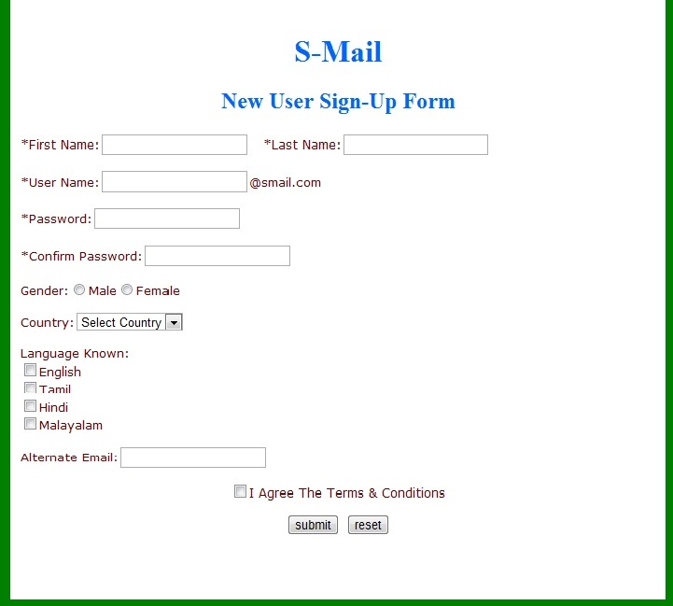

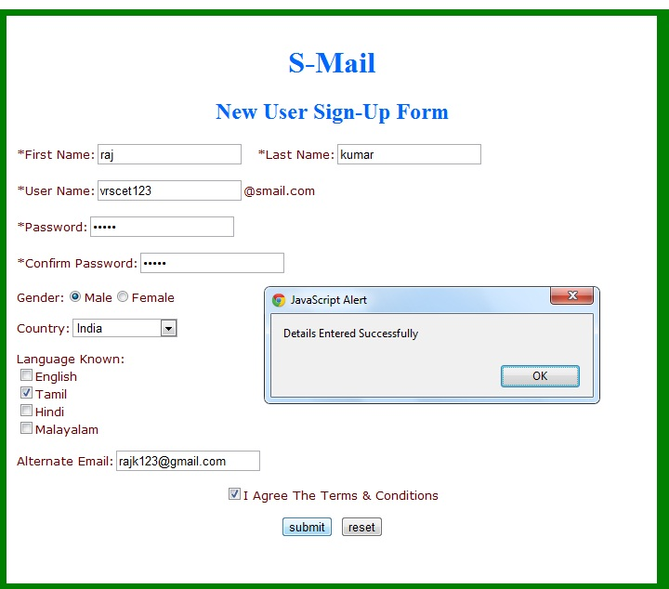

**Result:**

Thus the program for validating web form using javascript has been executed and the output is verified successfully.

**Ex No – 6 STUDENT QUIZ CONTEST-VBSCRIPT**

**Aim:** To create client side script for student quiz contest using vbscript

Step-1: Create a html file using notepad.

Step-2: Write a code to display the user details like Name, Password and Email.

Step-3: Create another html file using notepad.

Step-4: On submission of user details this html file should open.

Step-5: On clicking the reset button all the text boxes should be erased.

Step-6: Stop the program.

**PROGRAM:**

**login.html:**

<html>

<head>

<title> Login </title>

</head>

<script type="text/vbscript">

Function fn()

If log1.uname.value=log1.pword.value Then

msgbox"succcesfully login"

Else

msgbox"not succesfully login"

End If

End Function

</script>

<body>

<center><br><br>

<h><b>LOGIN FORM </b></h><br>

<br><br>

<form name="log1" method="post" action="Home.html">

<br>

Enter the username:

<input type="text" name="uname">

<br>

<br>

Enter the password:

<input type="password" name="pword">

<br>

<br>

<center><input type="button" value=" Login " onclick="fn()"></center>

<br>

<input type="reset" value="Reset" >

</form>

</center>

</body>

</html>

**home.html:**

<html>

<head>

<marquee>

<h1>ONLINE QUIZ </h1>

</marquee>

</head>

<body>

<center>

<img src="quiz.jpg" >

</center>

<font size="10" color="red" >

<ol>

<li><a href="QUIZINC.html">C</a>

<li><a href="net.html">NETWORKS</a>

<li><a href="wt.html">WEB TECHNOLOGY</a>

</ol>

</font>

</body>

</html>

**cquiz.html:**

<html>

<head>

<center>

<h1>C PROGRAMING</h1>

</center>

<script language="vbscript">

sub check1()

If f.r1(0).checked=True Then

Msgbox "correct"

else

Msgbox "try again"

End if

End sub

sub check2()

If f.r2(2).checked=True Then

Msgbox "correct"

else

Msgbox "try again"

End if

End sub

sub check3()

If f.r3(2).checked=True Then

Msgbox "correct"

else

Msgbox "try again"

End if

End sub

sub check4()

If f.r4(0).checked=True Then

Msgbox "correct"

else

Msgbox "try again"

End if

End sub

sub score()

s=0

If f.r1(0).checked=True Then

s=s+1

End if

If f.r2(2).checked=True Then

s=s+1

End if

If f.r3(2).checked=True Then

s=s+1

End if

If f.r4(0).checked=True Then

s=s+1

End if

msgbox s

End sub

</script>

</head>

<body>

<font size="5">

<form name="f">

1. Function in c returns -------- value

<br>

<input type="radio" name="r1">One value

<input type="radio" name="r1">More than One value

<input type="radio" name="r1">no value

<input type="radio" name="r1">None of the above

<input type="button" value="check" onClick="check1()">

<br>

<br>

2. Stack follows ---------- Principle

<br>

<input type="radio" name="r2">RUFO

<input type="radio" name="r2">FIFO

<input type="radio" name="r2">LIFO

<input type="radio" name="r2">None of the Above

<input type="button" value="Check" onClick="check2()">

<br>

<br>

3. enum is a

<br>

<input type="radio" name="r3">Primary data type

<input type="radio" name="r3">Class

<input type="radio" name="r3">user_define data type

<input type="radio" name="r3">None of the above

<input type="button" value="check" onClick="check3()">

<br>

<br>

4. char data type value

<br>

<input type="radio" name="r4">1

<input type="radio" name="r4">2

<input type="radio" name="r4">3

<input type="radio" name="r4">4

<input type="button" value="check" onClick="check4()">

<center>

<br>

<br>GRADE<br>

<input type="button" value="CLICK ME" onClick="score()">

</center>

</font>

</form>

</body>

</html>

**net.html:**

<html>

<head>

<center>

<h1>NETWORKS</h1>

</center>

<script language="vbscript">

dim s

s=0

sub check1()

If f.r1(0).checked=True Then

Msgbox "correct"

else

Msgbox "try again"

End if

End sub

sub check2()

If f.r2(3).checked=True Then

Msgbox "correct"

else

Msgbox "try again"

End if

End sub

sub check3()

If f.r3(1).checked=True Then

Msgbox "correct"

else

Msgbox "try again"

End if

End sub

sub check4()

If f.r4(0).checked=True Then

Msgbox "correct"

else

Msgbox "try again"

End if

End sub

sub score()

s=0

If f.r1(0).checked=True Then

s=s+1

End if

If f.r2(3).checked=True Then

s=s+1

End if

If f.r3(1).checked=True Then

s=s+1

End if

If f.r4(0).checked=True Then

s=s+1

End if

msgbox s

End sub

</script>

</head>

<body>

<font size="5">

<form name="f">

1. TCP means --------

<br>

<input type="radio" name="r1">Transmission Control Protocol

<input type="radio" name="r1">Transfer Control Protocol

<input type="radio" name="r1">Transfer Combine Protocol

<input type="radio" name="r1">Transmission Control package

<input type="button" value="check" onClick="check1()">

<br>

<br>

2. Node that is connected to two or more networks is commonly called as

<br>

<input type="radio" name="r2">node

<input type="radio" name="r2">Link

<input type="radio" name="r2">topology

<input type="radio" name="r2">Router

<input type="button" value="Check" onClick="check2()">

<br>

<br>

3. E-mail uses_________ communication protocol

<br>

<input type="radio" name="r3">MIME

<input type="radio" name="r3">SMTP

<input type="radio" name="r3">HTTP

<input type="radio" name="r3">None of the above

<input type="button" value="check" onClick="check3()">

<br>

<br>

4. _______is the most powerful of the redundancy checking techniques, is based

on binary division

<br>

<input type="radio" name="r4">CRC

<input type="radio" name="r4">checksum

<input type="radio" name="r4">lrc

<input type="radio" name="r4">Vrc

<input type="button" value="check" onClick="check4()">

<br>

<center>GRADE

<input type="button" value="CLICK ME" onClick="score()">

</center>

</form>

</font>

</body>

</html>

**wt.html:**

<html>

<head>

<h1>

<center> WEB TECHNOLOGY</center>

</h1>

<script language="vbscript">

dim s

s=0

sub check1()

If f.r1(0).checked=True Then

Msgbox "correct"

else

Msgbox "try again"

End if

End sub

sub check2()

If f.r2(1).checked=True Then

Msgbox "correct"

else

Msgbox "try again"

End if

End sub

sub check3()

If f.r3(3).checked=True Then

Msgbox "correct"

else

Msgbox "try again"

End if

End sub

sub check4()

If f.r4(1).checked=True Then

Msgbox "correct"

else

Msgbox "try again"

End if

End sub

sub check4()

If f.r4(0).checked=True Then

Msgbox "correct"

else

Msgbox "try again"

End if

End sub

sub score()

s=0

If f.r1(0).checked=True Then

s=s+1

End if

If f.r2(1).checked=True Then

s=s+1

End if

If f.r3(3).checked=True Then

s=s+1

End if

If f.r4(0).checked=True Then

s=s+1

End if

msgbox s

End sub

</script>

</head>

<body>

<form name="f">

<font size="4">

1. What does vlink means

<br>

<input type="radio" name="r1">visited link

<input type="radio" name="r1">active link

<input type="radio" name="r1">very good link

<input type="radio" name="r1">very active link

<input type="button" value="check" onClick="check1()">

<br>

<br>

2. Anchor tags used for ?

<br>

<input type="radio" name="r2">audio voice text

<input type="radio" name="r2">adding link to a page

<input type="radio" name="r2">align text

<input type="radio" name="r2">None of the above

<input type="button" value="Check" onClick="check2()">

<br>

<br>

3. Xml is a

<br>

<input type="radio" name="r3"> should use only small letters

<input type="radio" name="r3">should use only caps

<input type="radio" name="r3">non case sensitive

<input type="radio" name="r3">case sensitive

<input type="button" value="check" onClick="check3()">

<br>

<br>

4. To create a bulletted list

<br>

<input type="radio" name="r4">ol

<input type="radio" name="r4">ul

<input type="radio" name="r4">dl

<input type="radio" name="r4">dtd

<input type="button" value="check" onClick="check4()">

<br>

<center>

GRADE

<input type="button" value="Clik Me" onClick="score()">

</center>

</font>

</form>

</body>

</html>

**OUTPUT:**

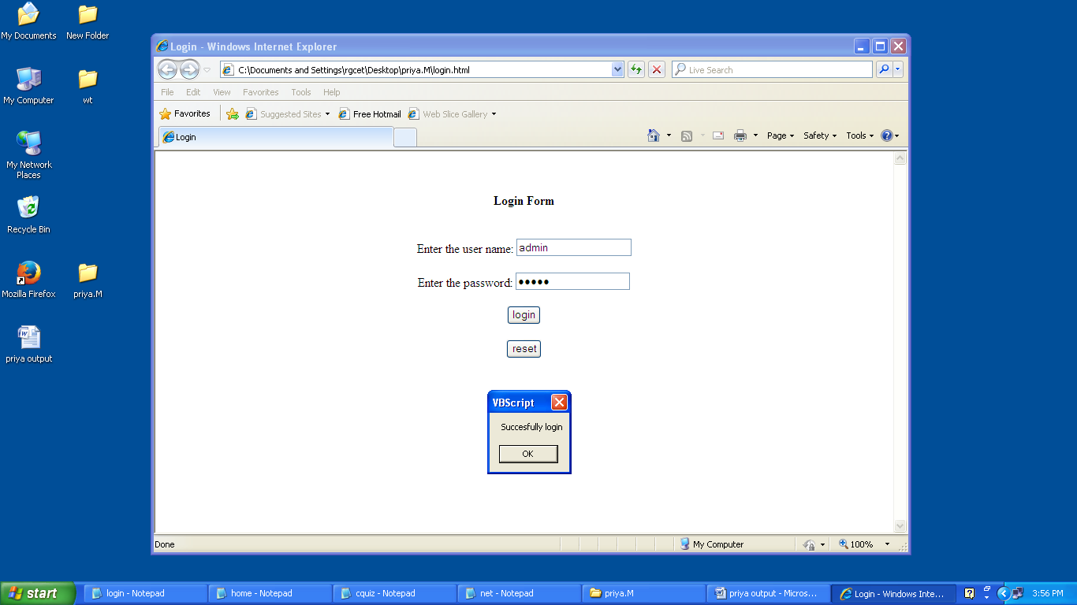

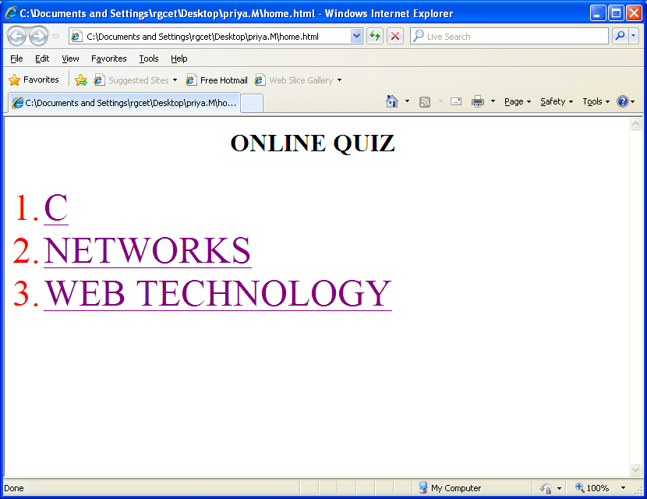

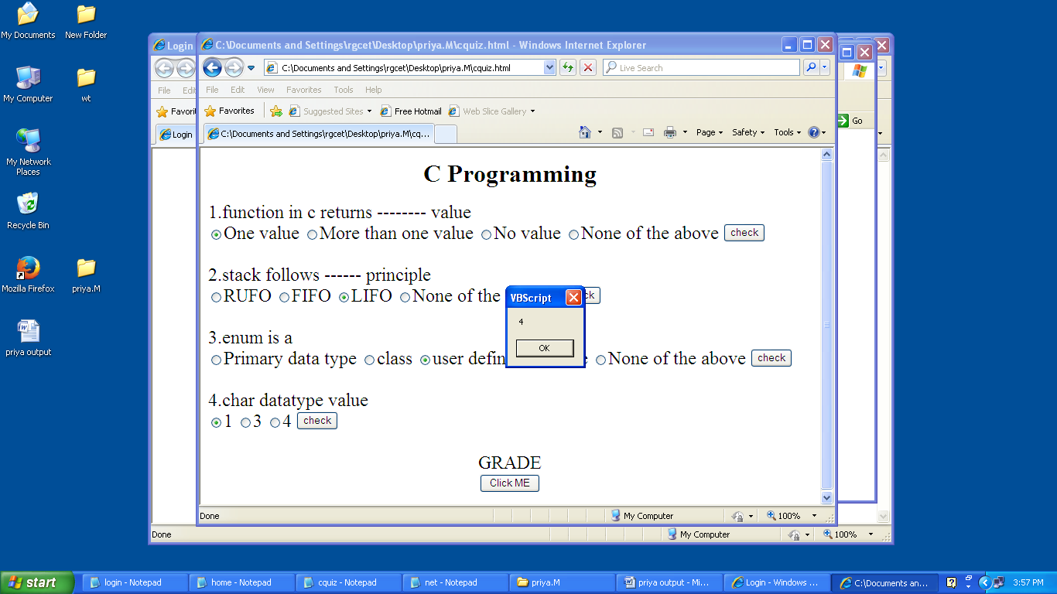

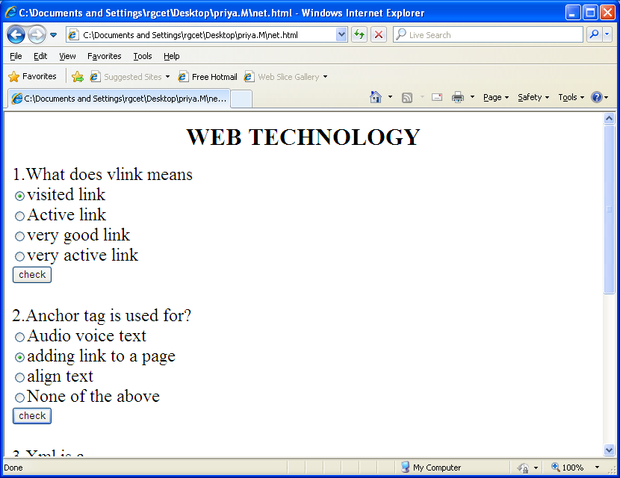

**Result:** The client side script for student quiz contest using vbscript has been executed and the output is verified successfully

**7 .SCIENTIFIC CALCULATOR**

**Aim :**

**To create a scientific calculator for performing mathematical calculation.**

**Algorithm:**

1. At first Insert a <form> element within <body> tag.  
2. Create a table using <table> .....</table> tag.   
3. Insert two types of Input text and button within table data of table row using <tr><td>....</td></tr> tag.  
4. Assign OnClick event for all the buttons having numbers and arithmetic operators.  
5. Give blank value for Clear(C) button.  
6. Use eval() function to evaluate the numbers on OnClick event of equal to sign button.

**PROGRAM:**

**sci_calc.html**

<html>

<title> SCIENTIFIC CALCULATOR </title>

<head><h1> SCIENTIFIC CALCULATOR<h1></head>

<body bgcolor="cyan">

<center>

<form name="sci-calc">

<table cellspacing="0" cellpadding="1">

<tr>

<td colspan="5" align="center">

<input name="display" value="0" size="28" maxlength="25">

</td>

</tr>

<tr>

<td align="center">

<input type="button" value="exp" onclick="if (checkNum(this.form.display.value)) { exp(this.form)}">

</td>

<td align="center">

<input type="button" value="7" onclick="addChar(this.form.display,'7')" </td>

<td align="center">

<input type="button" value="8" onclick="addChar(this.form.display,'8')" </td>

<td align="center">

<input type="button" value="9" onclick="addChar(this.form.display,'9')" </td>

<td align="center">

<input type="button" value="/" onclick="addChar(this.form.display,'/')" </td></tr>

<tr>

<td align="center">

<input type="button" value="ln" onclick="if (checkNum(this.form.display.value)) { ln(this.form)}">

</td>

<td align="center">

<input type="button" value="4" onclick="addChar(this.form.display,'4')" </td>

<td align="center">

<input type="button" value="5" onclick="addChar(this.form.display,'5')" </td>

<td align="center">

<input type="button" value="6" onclick="addChar(this.form.display,'6')" </td>

<td align="center">

<input type="button" value="*" onclick="addChar(this.form.display,'*')" </td></tr>

<tr>

<td align="center">

<input type="button" value="sqrt" onclick="if (checkNum(this.form.display.value)) { sqrt(this.form)}">

</td>

<td align="center">

<input type="button" value="1" onclick="addChar(this.form.display,'1')" </td>

<td align="center">

<input type="button" value="2" onclick="addChar(this.form.display,'2')" </td>

<td align="center">

<input type="button" value="3" onclick="addChar(this.form.display,'3')" </td>

<td align="center">

<input type="button" value="-" onclick="addChar(this.form.display,'-')" </td></tr>

<tr>

<td align="center">

<input type="button" value="sq" onclick="if (checkNum(this.form.display.value)) { square(this.form)}">

</td>

<td align="center">

<input type="button" value="0" onclick="addChar(this.form.display,'0')" </td>

<td align="center">

<input type="button" value="." onclick="addChar(this.form.display,'.')" </td>

<td align="center">

<input type="button" value="+/-" onclick="changeSign(this.form.display)" </td>

<td align="center">

<input type="button" value="+" onclick="addChar(this.form.display,'+')" </td></tr>

<td>

<td align="center">

<input type="button" value="("onclick="addChar(this.form.display,'(')"></td>

<td align="center">

<input type="button" value="cos"onclick="if (checkNum(this.form.display.value)) { cos(this.form)}" </td>

<td align="center">

<input type="button" value="sin" onclick="if (checkNum(this.form.display.value)) { sin(this.form)}" </td>

<td align="center">

<input type="button" value="tan" onclick="if (checkNum(this.form.display.value)) { tan(this.form)}" </td>

<td align="center">

<input type="button" value=")" onclick="addChar(this.form.display,')')" </td></tr>

<tr>

<td align="center">

<input type="button" value="clear" onclick="this.form.display.value=0"></td>

<td align="center" COLSPAN="3">

<input type="button" value="backspace" onclick="deleteChar(this.form.display)"></td>

<td align="center">

<input type="button" value="enter" name="enter" onclick="if (checkNum(this.form.display.value)) {compute (this.form)}">

</td>

</tr>

</table>

</form>

<script language="JavaScript">

function addChar(input,character)

{

if(input.value==null || input.value=="0")

input.value=character

else

input.value+=character

}

function cos(form)

{

form.display.value=Math.cos(form.display.value);

}

function sin(form)

{

form.display.value=Math.sin(form.display.value);

}

function tan(form)

{

form.display.value=Math.tan(form.display.value);

}

function sqrt(form)

{

form.display.value=Math.sqrt(form.display.value);

}

function ln(form)

{

form.display.value=Math.log(form.display.value);

}

function exp(form)

{

form.display.value=Math.exp(form.display.value);

}

function deleteChar(input)

{

input.value=input.value.substring(0,input.value.length-1)

}

function changeSign(input)

{

if(input.value.substring(0,1)=="-")

inputvalue=input.value.substring(1,input.value.length)

else

input.value="-"+input.value

}

function compute(form)

{

form.display.value=eval(form.display.value)

}

function square(form)

{

form.display.value=eval(form.display.value)*eval(form.display.value)

}

function checkNum(str)

{

for(var i=0;i<str.length;i++)

{

var ch=str.substring(i,i+1)

if(ch<"0"||ch>"9")

{

if(ch!="/" && ch!="*" && ch!="+" && ch!="-" && ch!="." && ch!="(" && ch!=")")

{

alert("invalid entry!")

return false

}

}

}

return true;

}

</script>

</center>

</body>

</html>

**OUTPUT:**

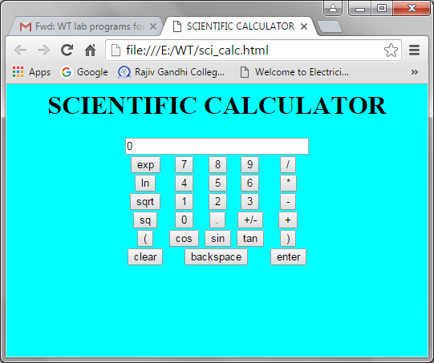

**Result**:

Thus the scientific calculator for performing mathematical calculation was created and executed succesfully.

**8. ONCAMPUS REGISTRATION FORM**

**Aim:**

To create an on-campus registration form to collect details about the students.

**Algorithm:**

1. Initialize the web page using **HTML** tag.
2. Insert the heading of the page.
3. The body of the page contains the form to enter details.
4. Conclude the html tag.
5. Save the file using “.html” extension.

**SOURCE PROGRAM:**

**Registration.html**

<html>

<head>

<title> RESUME REGISTRATION</title>

<h1>

<i>RESUME REGISTRATION</i>

</h1>

<script language="javascript">

function namevalidate()

{

var win;

win=open("about:blank","namevalidate",height=500,width=700);

win.document.writeln("<html><head><title>REPORT</title></head>

<body bgcolor=#B5A642><font face=arial><b><center><h1>RESUME REPORT </center></b></h1>");

win.document.writeln("Name :"+resume.name.value+"<br>");

win.document.writeln("Address :"+resume.addr.value+"<br>");

win.document.writeln("Date of Birth :"+resume.day.value+"-"+resume.month.value+"-

"+resume.year.value+"<br>");

for(var i=0;i<=resume.gender.length;i++)

{

if(resume.gender[i].checked)

{

win.document.writeln("Gender:"+resume.gender[i].value+"<br>");

break;

}

}

for(var i=0;i<=resume.course.length;i++)

{

if(resume.course[i].checked)

{

win.document.writeln("Qualification:"+resume.course[i].value+"<br>");

break;

}

}

win.document.writeln("University:"+resume.univer.value+"<br>");

win.document.writeln("Nature of Job:"+resume.job.value+"<br>");

for(var i=0;i<=resume.mode.length;i++)

{

if(resume.mode[i].checked)

{

win.document.writeln("Mode of Interview :"+resume.mode[i].value+"<br>");

break;

}

}

win.document.writeln("Area of Interest :");

var j="";

for(var i=0;i<resume.area.length;i++)

{

if(resume.area[i].checked)

{

j=j+resume.area[i].value+",";

}

}

<!-- win.document.writeln(j+"."+"<br>");-->

win.document.writeln(j.substring(0,j.length-1)+"."+"<br>");

win.document.writeln("File :"+resume.file.value+"<br>");

win.document.writeln("</font></body></html>");

}

</script>

</head>

<body bgcolor="#sddf6y">

<legend><b>PROFILE DETAILS</b></legend>

<br>

<font face="arial" size="4">

<form name="resume">

<table>

<tr>

<td>

Name:

</td>

<td>

<input type="text" name="name" text color="red">

</td>

</tr>

<tr>

<td>

Address:

</td>

<td>

<textarea name="addr"cols="30" rows="5">

</textarea>

</td>

</tr>

<tr>

<td>

Date of Birth:

</td>

<td>

<select type="dropdown" name="day">

<option value="01">01</option>

<option value="02">02</option>

<option value="03">03</option>

<option value="04">04</option>

<option value="05">05</option>

<option value="06">06</option>

<option value="07">07</option>

<option value="08">08</option>

<option value="09">09</option>

<option value="10">10</option>

<option value="11">11</option>

<option value="12">12</option>

<option value="13">13</option>

<option value="14">14</option>

<option value="15">15</option>

<option value="16">16</option>

<option value="17">17</option>

<option value="18">18</option>

<option value="19">19</option>

<option value="20">20</option>

<option value="21">21</option>

<option value="22">22</option>

<option value="23">23</option>

<option value="24">24</option>

<option value="25">25</option>

<option value="26">26</option>

<option value="27">27</option>

<option value="28">28</option>

<option value="29">29</option>

<option value="30">30</option>

<option value="31">31</option>

</select>

<select type="dropdown" name="month">

<option value="Jan">Jan</option>

<option value="Feb">Feb</option>

<option value="Mar">Mar</option>

<option value="Apr">Apr</option>

<option value="May">May</option>

<option value="Jun">Jun</option>

<option value="Jul">Jul</option>

<option value="Aug">Aug</option>

<option value="Sep">Sep</option>

<option value="Oct">Oct</option>

<option value="Nov">NOv</option>

<option value="Dec">Dec</option>

</select>

<select type="dropdown" name="year">

<option value="1980">1980</option>

<option value="1981">1981</option>

<option value="1982">1982</option>

<option value="1980">1983</option>

<option value="1984">1984</option>

<option value="1985">1985</option>

<option value="1986">1986</option>

<option value="1987">1987</option>

<option value="1988">1988</option>

<option value="1989">1989</option>

<option value="1990">1990</option>

<option value="1991">1991</option>

<option value="1992">1992</option>

<option value="1993">1993</option>

<option value="1994">1994</option>

<option value="1995">1995</option>

<option value="1996">1996</option>

</select>

</td>

</tr>

<tr>

<td>

Gender:

</td>

<td>

<input type="radio" name="gender" value="Male">Male

<input type="radio" name="gender" value="Female">Female

</td>

</tr>

<tr>

<td>

Qualification:

</td>

<td>

<input type="radio" name="course" value="UG">UG

<input type="radio" name="course" value="PG">PG

<input type="radio" name="course" value="PHD">PHD

</td>

</tr>

<tr>

<td>

University:

</td>

<td>

<select name="univer">

<option value="Pondicherry University">Pondicherry University</option>

<option value="Anna University">Anna University</option>

<option value="Annamalai University">Annamalai University</option>

</select>

</td>

</tr>

<tr>

<td>

Nature of Job:

</td>

<td>

<select name="job">

<option value="Software Engineer">Software Engineer

<option value="Software Analyst">Software Analyst

</select>

</td>

</tr>

<tr>

<td>

Mode of Interview:

</td>

<td>

<input type=radio name="mode" value="Phone">Phone

<input type=radio name="mode" value="System">System

<input type=radio name="mode" value="Walk in">Walk in

</td>

</tr>

<tr>

<td>

Area of Interest:

</td>

<td>

<input type=checkbox name="area" value="Network Architecture">Network Architecture

<input type=checkbox name="area" value="OS">OS

<input type=checkbox name="area" value="c,c++">c,c++

<input type=checkbox name="area" value="DBMS">DBMS

<input type=checkbox name="area" value=Java>Java

<input type=checkbox name="area" value="OOps">OOPS

</td>

</tr>

<tr>

<td>

Upload your Resume

</td>

<td>

<input type="file" name="file">

</td>

</tr>

<tr>

<td colspan="2">

<input type="button" value="Submit" onClick="namevalidate()">

<input type="reset">

</td>

</tr>

</table>

</form>

</font>

</body>

</html>

**Output :**

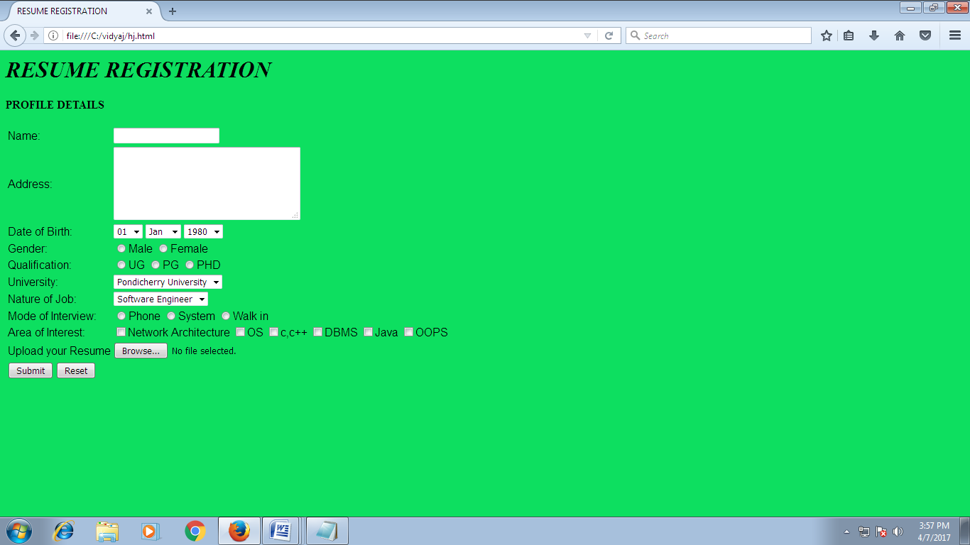

**Result :**

Thus the program to create an on-campus registration form to collect details about the students was executed successfully.

**9.Internet Information Server (IIS)**

**AIM:**

To study the configuration of Internet Information Server (IIS).

**Theory :**

* **Internet Information Services** (**IIS**, formerly **Internet Information Server**) is anextensible [web server](http://en.wikipedia.org/wiki/Web_server) created by [Microsoft](http://en.wikipedia.org/wiki/Microsoft) for use with [Windows NT](http://en.wikipedia.org/wiki/Windows_NT) family.
* IS (Internet Information Server) is a group of Internet [servers](http://whatis.techtarget.com/definition/server) (including a Web or Hypertext Transfer Protocol server and a [File Transfer Protocol](http://searchenterprisewan.techtarget.com/definition/File-Transfer-Protocol) server) with additional capabilities for Microsoft's [Windows NT](http://searchwinit.techtarget.com/definition/Windows-NT) and [Windows 2000](http://searchenterprisedesktop.techtarget.com/definition/Windows-2000) Server operating systems.
* IIS supports [HTTP,](http://en.wikipedia.org/wiki/HTTP) [HTTPS,](http://en.wikipedia.org/wiki/HTTPS) [FTP,](http://en.wikipedia.org/wiki/File_Transfer_Protocol) [FTPS,](http://en.wikipedia.org/wiki/FTPS) [SMTP](http://en.wikipedia.org/wiki/Simple_Mail_Transfer_Protocol) and [NNTP.](http://en.wikipedia.org/wiki/Network_News_Transfer_Protocol) It has been an integral part of the Windows NT family since [Windows NT 4.0,](http://en.wikipedia.org/wiki/Windows_NT_4.0) though it may be absent from some editions (e.g. Windows XP Home edition).
* IIS is not turned on by default when Windows is installed. The IIS Manager is accessed through the [Microsoft Management Console](http://en.wikipedia.org/wiki/Microsoft_Management_Console) or Administrative Tools in the Control Panel.
* IIS is Microsoft's entry to compete in the Internet server market that is also addressed by [Apache,](http://searchcio-midmarket.techtarget.com/definition/Apache) Sun Microsystems, O'Reilly, and others.
* Web developers can use Microsoft's [Active Server Page](http://searchwindowsserver.techtarget.com/definition/Active-Server-Page) (ASP) technology, which means that applications - including [ActiveX controls](http://searchenterprisedesktop.techtarget.com/definition/ActiveX-control) - can be imbedded in Web pages that modify the content sent back to users. Developers can also write programs that filter requests and get the correct Web pages for different users by using Microsoft's Internet Server Application Program Interface [(ISAPI)](http://searchwindowsserver.techtarget.com/definition/ISAPI) interface. ASPs and ISAPI programs run more efficiently than common gateway interface (CGI) and server-side include (SSI) programs, two current technologies.
* With IIS, Microsoft includes a set of programs for building and administering Web sites, a search engine, and support for writing Web-based applications that access [databases.](http://searchsqlserver.techtarget.com/definition/database) Microsoft points out that IIS is tightly integrated with the Windows NT and 2000 Servers in a number of ways, resulting in faster Web page serving.

**Step 1 - Control Panel**



Go to Control Panel -> Add Remove Programs

**Step 2 - Windows Configuration**

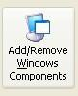

Click Add/Remove Windows Components

**Step 3 - Select IIS**

The Windows Component Wizard will appear. You need to select the Internet Information Services (IIS) checkbox and then click Next.

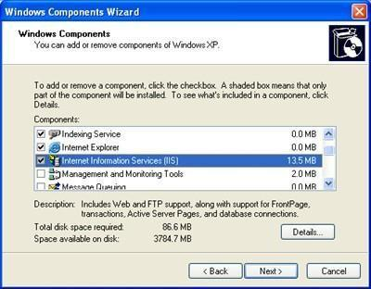

**Step 4 - Insert Your XP Professional CD**

Now you will probably be asked to insert your Windows XP Professional CD.

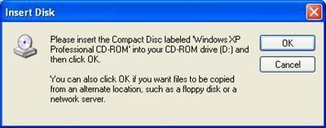

Do not be concerned if you do not see this step. It means your system has probably been installed via the network, meaning you don't have to locate and insert your CD.

**Step 5 - Installing**

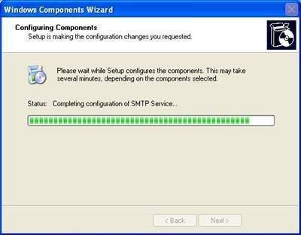Once your WIndows XP Professional CD (or network based installation) is available you will see a window like the following, indicating that Internet Information Services is being installed.

**Step 6 - Finished**

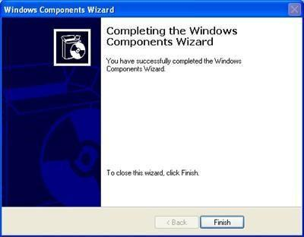When installation has finished you will see the following window, which shows that you have successfully installed Microsoft Internet Information Services 5.1.

**Step 7 - Configure ASP.NET**

This step registers Microsofts "DOT NET" technology within the IIS Web Server.

**Result :**

Thus the configuration of Internet Information Server (IIS) is studied.

**10.Tomcat Apache Server**

**AIM:**

To study the configuration ofTomcat Apache Server.

**How to install and configure the Tomcat Server**

Here we are illustrating the installation process only for Windows. Steps involved in installation and configuration process for Tomcat 6.0.10 are illustrated below:

**Step 1: Installation of JDK:** Don't forget to install JDK on your system (if not installed) becauseany tomcat requires the Java 1.5 (Java 5) and Java 1.6 (Java 6) and then set the class path (environment variable) of JDK.

**Step 2: Setting the class path variable for JDK:** Two methods are there to set the classpath.

1. Set the class path using the following command.

set PATH="C:\Program Files\Java\jdk1.5.0_08\bin";%PATH%

1. The other way of setting the class path variable is:

First right click on the My Computer->properties->advance->Environment Variables->path.

Set bin directory path of JDK in the path variable.

**Step 3:** Now it's time to shift on to the installation process of Tomcat 6.0.10. It takes various stepsfor installing and configuring the Tomcat 6.0.

For Windows, Tomcat comes in two forms: **.**zip file and the Windows installer (**.**exe file). Here we are exploring the installation process by using the **.**exe file. The directory C:\apache-tomcat-6.0.10 is the common installation directory as it is pre-specified C:\ as the top-level directory. First unpack the zipped file and simply execute the **.**exe file.

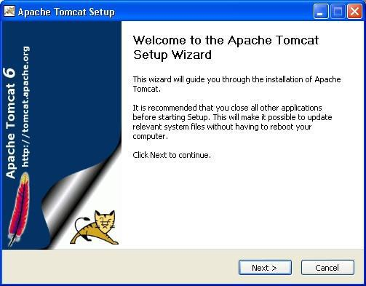

The above shown screen shot is the first one shown in the installation process. Just click on the Next button to proceed the installation process.

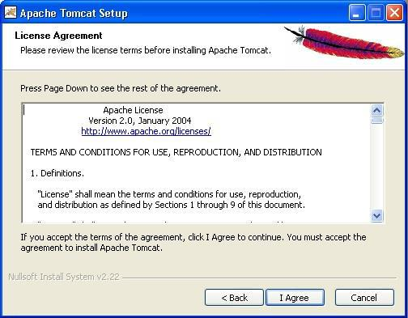

Click “I Agree” button to continue the installation process.

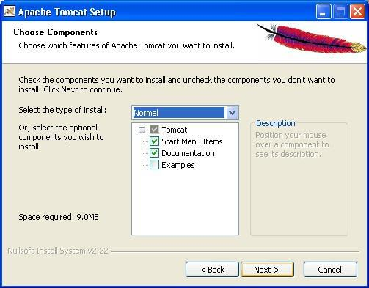

Click next to go with the default components choosen

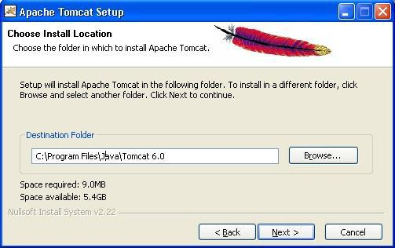

Choose the location for the Tomcat files as per your convenience. You can also choose the default location.

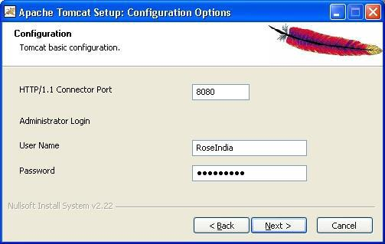

Now choose the port number on which you want to run the tomcat server. Tomcat uses the port number 8080 as its default value. But Most of the people change the port number to 80 because in this case the user is not required to specify the port number at request time. But we are using here the default port number as 8080. Choose the user name and password as per your convenience. We can change the port number even the installation process is over. For that, go to the specified location as " Tomcat 6.0 \conf \server.xml ". Within the server.xml file choose "Connector" tag and change the port number. e.g While using the port number 8080, give the following request in the address bar as:

**Default Port:** http//localhost:8080/index.jsp

In case of port number number 80 just type the string illustrated below in the address bar: **New Port:** http://localhost/index.jsp

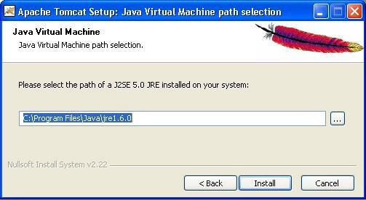Note that we do no need to specify any port number in the URL.

Now click on the Next button to proceed the installation process.

The installation process shows the above screen as the next window. This window asks for the location of the installed Java Virtual Machine. Browse the location of the JRE folder and click on the Install button.

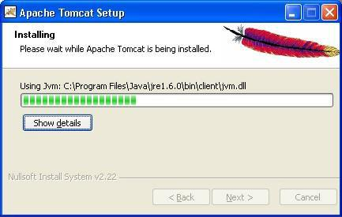This will install the Apache tomcat at the specified location.

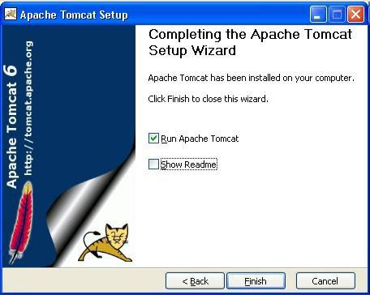To get the information about installer click on the "Show details" button

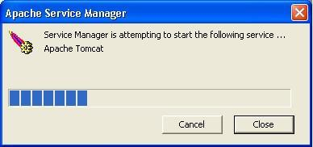After completion of installation process it will display the window like the above one.

On clicking at Finish button, a window like the above one will display a message printed on the window given below.

After successfully installing, a shortcut icon to start the tomcat server appears in the icon tray of the task bar as shown above. Double clicking the icon, displays the window of Apache Manager for Tomcat. It will show the "Startup type" as manual since we have changed the destination folder for tomcat during the installation process. Now we can configure the other options like "Display name" and "Description" .We can also start, stop and restart the service from here.

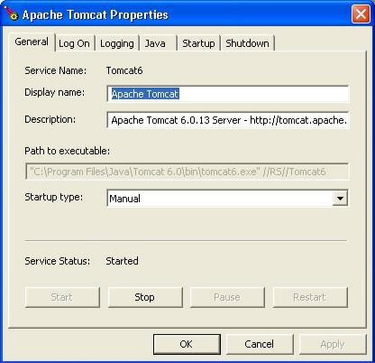

**If installation process completes successfully then a window as shown below will appear.**

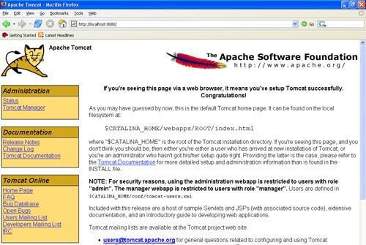

Now, set the environment variable for tomcat:

**Step 4: Setting the JAVA_HOME Variable:** Purpose of setting the environment variable JAVA_HOMEis to specify the location of the java run time environment needed to support the Tomcat else Tomcat server does

not run. This variable contains the path of JDK installation directory. Note that it should not contain the path up to bin folder.

set JAVA_HOME=C:\Program Files\Java\jdk1.5.0_08 Here, we have taken the URI path according to our installation convention **For Windows XP, Go**

**through the following steps:**

Start menu->Control Panel->System->Advanced tab->Environment Variables->New->set the Variable Name as JAVA_HOME and Variable Value as C:\Program Files\Java\jdk1.6.0 and then click on all the three ok buttons one by one. It will set the JDK path.

**For Windows 2000 and NT, follow these steps:**

Start->Settings->Control Panel->System->Environment Variable->New->set the Variable Name as JAVA_HOME and Variable Value as C:\Program Files\Java\jdk1.6.0 and then click on all the three ok button one by one. It will set the JDK path

Now , **Start the Tomcat Server :** Start the tomcat server from the bin folder of Tomcat 6.0 directory by double clicking the " tomcat6.exe " file. You can also create a shortcut of this .exe file at your desktop.

**Stop the Tomcat Server:** Stop the server by pressing the "Ctrl + c" keys.

**RESULT:**

Thus the configuration of Tomcat Apache Server is studied.

### 

### 11.SIMPLE JSP PROGRAMS

### AIM:

To create a simple java server page (JSP) programs such as Date, Page Inclusion and Arithmetic

operations.

### PROCEDURE:

Step 1: Create a jsp file using page directives. Step 2: Using include directives and file attribute Step 3: Using expression, display the date.

Step 4: In arithmetic operations, create the radio buttons for addition, subtraction, multiplication and division.

Step 5: Using expression, to display the calculated values. Step 6: Save the filename.jsp

Step 7: Execute the web page in Apache tomcat server and Internet explorer.

### SOURCE PROGRAM:

**Date.jsp:**

<%@page language ="java"%>

<%--This is the HTML content--%>

<HTML>

<HEAD>

<TITLE>A Dynamic Content example</TITLE>

</HEAD>

<BODY bgcolor=*”#FFEAFF”*>

<H1>Welcome</H1><HR>

<H3>Today’s date and time:</H3>

<%--This is the JSP content that displays the server time by using the method Date()--%>

<%= **new** java.util.Date() %>

</BODY>

</HTML>

### OUTPUT:

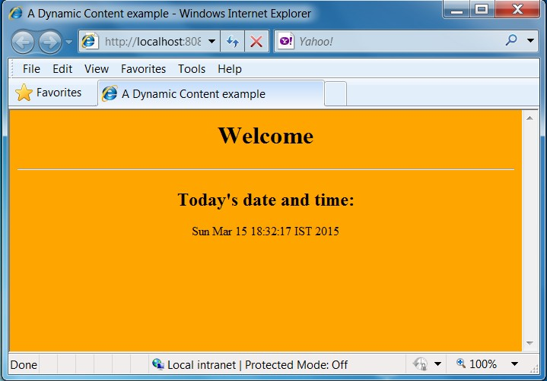

**FILE INCLUSION**

**First.jsp:**

<%@ page language="java" %>

<html>

<head>

<title> An Include example</title>

<body>

</head>

<h2>This is the content of first.jsp</h2><hr>

<%="Hello, welcome to the world of Java Server Pages!!!" %>

<%@ include file="second.jsp" %>

</body>

</html>

### Second.jsp:

<%@ page language="java" %>

<html>

<head>

<title> An Include example</title>

<body>

</head>

<h2>This is the content of second.jsp</h2><hr>

<%="Hope you’re having fun learning JSP" %>

</body>

</html>

### OUTPUT:

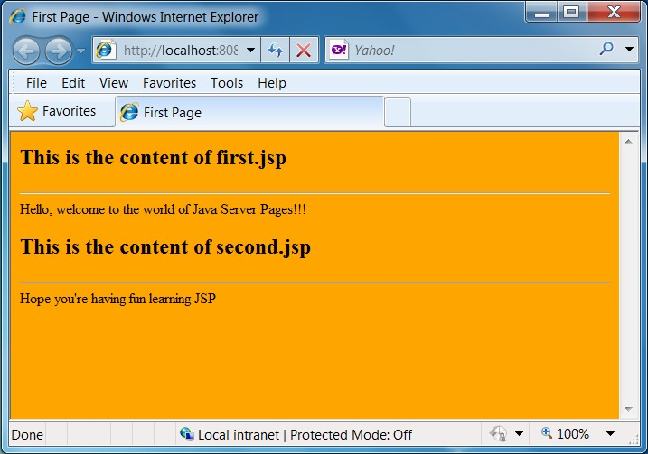

**Arithmetic operations**

**Input.html**

<html>

<body>

<head>

<title>ARITHMETIC OPEARTION</title></head>

<b><H1 align="center"><font color="green">

MATHEMATICAL FUNCTIONS</font></H1></b>

<form name="in" method="post" action="calculate.jsp">

<table align="center" cellpadding="5%" cellspacing="5%" border="3" bordercolor="#FF0000">

<tr>

<td> ENTER THE NO1 <input type="text" name="t1"/></td></tr>

<tr><td> ENTER THE NO2 <input type="text" name="t2" /></td></tr>

<tr><td><input name="radio" type="radio" value="add" />ADDITION </td></tr>

<tr><td><input name="radio" type="radio" value="sub" />SUBTRACTION</td></tr>

<tr></tr>

<tr><td><input name="radio" type="radio" value="mul" />MULTIPLICATION</td>

<td><input name="radio" type="radio" value="div" />DIVISION</td></tr></table>

<br /><br />

<table align="center" cellpadding="5%" cellspacing="5%" border="3" bordercolor="#FF0000">

<tr><td><input type="submit" name="b1" value="Submit here" /></td>

<td><input type="reset" name="re1" value="Reset here" /></td></tr>

</table></form></body></html>

**Calculate.jsp:**

<%@ page language="java"%>

<%@ page import="java.lang.*" %>

<html><body><head><title>Calculate Operation</title>

</head>

<% String str=request.getParameter("radio");

String str1=request.getParameter("t1");

String str2=request.getParameter("t2");

String output="";

int num1=0; int num2=0;

int num3=0;

num1=Integer.parseInt(str1);

num2=Integer.parseInt(str2);

if(str.equals("add"))

{

num3=num1+num2;

output="Addition";

}

if(str.equals("sub"))

{

num3=num1-num2;

output="Subtraction";

}

if(str.equals("mul"))

{

num3=num1*num2;

output="multiplication";

}

if(str.equals("div"))

{

num3=num1/num2;

output="Division";

} %>

<h1>The Selected mathematical function by you is:<%=output %></h1><br /><br />

<% Integer in =new Integer(num3);

out.println("<h3>The Result is </h3>" +in.toString());

%>

</body>

</html>

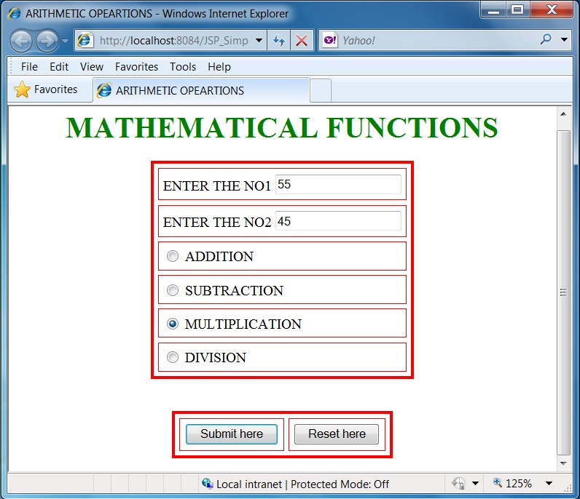

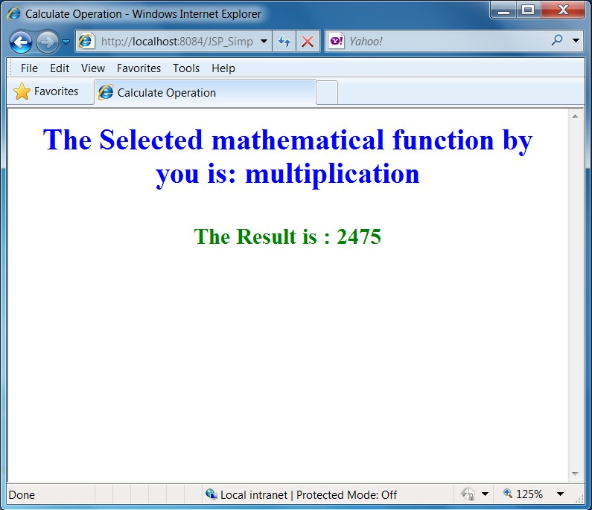

### RESULT:

Thus the date, file inclusion and arithmetic operations using jsp program have created and output verified.

### 12.LOGIN FORM

### AIM:

To check whether given user name and password is correct or not using JSP database connectivity.

### PROCEDURE:

Step 1: Create a login form for user name and password. If the given user name and password is correct, then it shows the “welcome” with their corresponding user name.

Step 2: If the user name and password didn’t match, it shows invalid user name.

Step 3: If the user is new, you can be able to register your details with first name, last name, email, user name and password. Then it shows successfully registered.

Step 4: Use the Oracle database connectivity for checking their user name and password.

Step 5: You can also update the password for specific user name. Then it shows successfully updated your password.

Step 6: Finally, we can able to logout.

### SOURCE PROGRAM:

**Index.jsp:**

<%@page language="java"%>

<html>

<head>

<title>Login Page</title>

</head>

<body>

<form method="post" action="login.jsp">

<center>

<table border="1" width="30%" cellpadding="3">

<thead>

<tr>

<th colspan="2"> Login Here </th>

</tr>

</thead>

<tbody>

<tr>

</tr>

<td> User Name </td>

<td> <input type="text" name="uname"/> </td>

<tr>

<td> Password </td>

<td> <input type="password" name="pass"/> </td>

</tr>

<tr>

</tr>

<tr>

</tr>

<td> <input type="submit" value="Login"/> </td>

<td> <input type="reset" value="Reset"/> </td>

<td colspan="2"> Yet Not Registered!! <a href="reg.jsp"> Register Here </a> </td>

</tbody>

</table>

</center>

</form>

</body>

</html>

### Reg.jsp:

<%@page language="java"%>

<html>

<head>

<title> Registration page </title>

</head>

<body>

<form method="post" action="registration.jsp">

<center>

<table border="1" width="30%" cellpadding="5">

<thead>

<tr>

</tr>

</thead>

<tbody>

<tr>

<th colspan="2"> Enter Your Information Here </th>

</tr>

<td> First Name </td>

<td> <input type="text" name="fname"/> </td>

<tr>

</tr>

<tr>

<td> Last Name </td>

<td> <input type="text" name="lname"/> </td>

<td> Email </td>

<td> <input type="text" name="email"/> </td>

</tr>

<tr>

<td> User Name </td>

<td> <input type="text" name="uname"/> </td>

</tr>

<tr>

<td> Password </td>

<td> <input type="password" name="pass"/> </td>

</tr>

<tr>

<td> <input type="submit" value="Submit"/> </td>

<td> <input type="reset" value="Reset"/> </td>

</tr>

<tr>

<td colspan="2"> Already registered!! <a href="index.jsp"> Login Here </a></td>

</tr>

</tbody>

</table>

</center>

</form>

</body>

</html>

### Registration.jsp:

<%@ page import ="java.sql.*" %>

<%

try

{

String user = request.getParameter("uname");

String pwd = request.getParameter("pass");

String fname = request.getParameter("fname");

String lname = request.getParameter("lname");

String email = request.getParameter("email");

Class.forName("oracle.jdbc.driver.OracleDriver");

Connection con =DriverManager.getConnection("jdbc:oracle:thin:@localhost:1521:XE","system","cse123");

Statement st = con.createStatement();

String query ="insert into reg values ('" + fname + "','" + lname + "','" + email + "','" + user + "','" + pwd+ "')";

st.executeUpdate(query); response.sendRedirect("Welcome.jsp");

}

catch(Exception e)

{

out.print(e);

}

%>

### Welcome.jsp:

<%@page language="java"%>

<html>

<head>

<title> Welcome page </title>

</head>

<body>

Registration is Successful.

Please Login Here <a href='index.jsp'> Go to Login </a>

</body>

</html>

### Login.jsp:

<%@ page language="java" import ="java.sql.*" %>

<%

String userid = request.getParameter("uname"); String pwd = request.getParameter("pass"); Class.forName("oracle.jdbc.driver.OracleDriver"); Connection con =

DriverManager.getConnection("jdbc:oracle:thin:@localhost:1521:XE","system","cse123"); Statement st = con.createStatement();

ResultSet rs;

rs = st.executeQuery("select * from reg"); int count =0;

while(rs.next())

{

String user = rs.getString(4); String pass = rs.getString(5);

if(user.equals(userid) && pass.equals(pwd))

{

count++;

}

}

if(count == 1)

{

session.setAttribute("userid", userid); out.println("welcome " + userid); out.println("<a href='logout.jsp'>Log out</a>"); response.sendRedirect("success.jsp");

}

if(count == 0)

{

out.println("Invalid password <a href='index.jsp'>try again</a>");

}

%>

### Success.jsp:

<%

if ((session.getAttribute("userid") == null) || (session.getAttribute("userid") == "")) {

%>

You are not logged in <br/>

<a href="index.jsp"> Please Login </a>

<% } else {

%>

Welcome <%=session.getAttribute("userid")%>

<a href='logout.jsp'> Log out </a>

<%

}

%>

### Logout.jsp:

<%@page language="java"%>

<html>

<head>

<title> Login out </title>

</head>

<body>

<%

session.setAttribute("userid", null); session.invalidate(); response.sendRedirect("index.jsp");

%>

</body>

</html>

### OUTPUT:

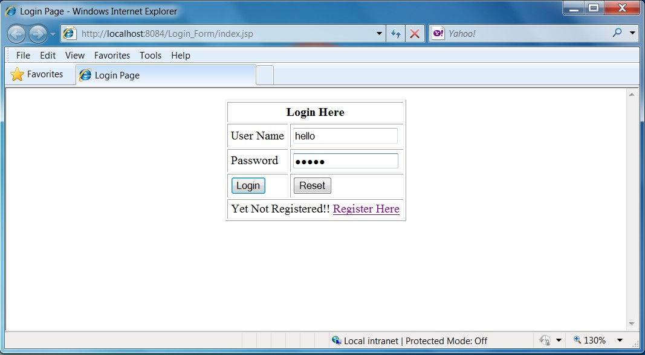

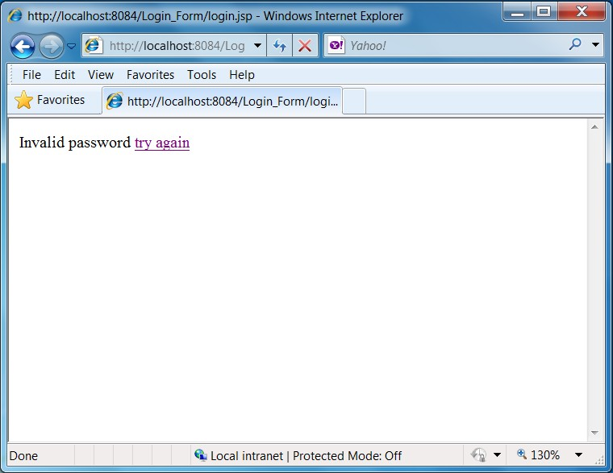

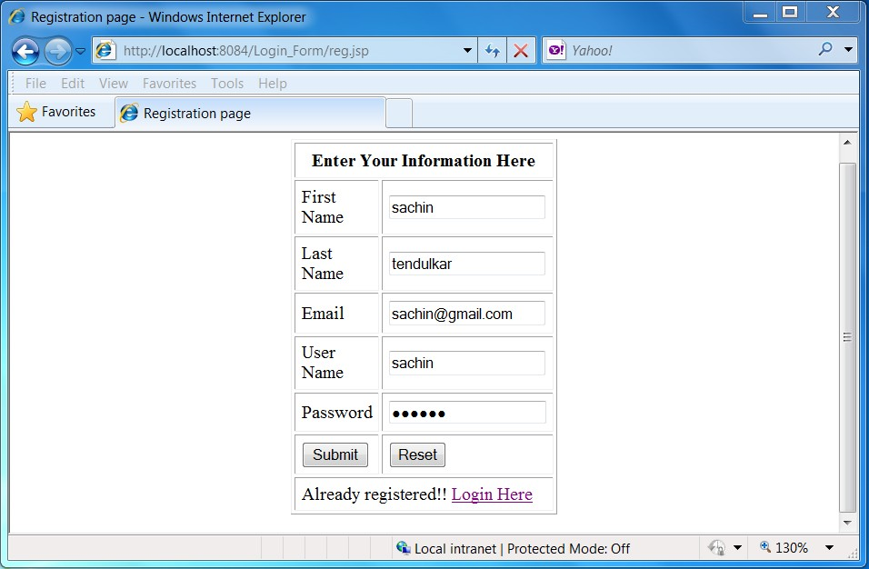

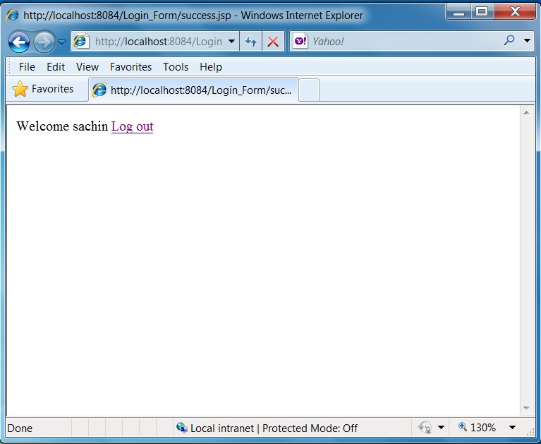

### DATABASE CREATION:

create table reg (fname varchar(20),lname varchar(20),email varchar(20), user varchar(20) primary key,pass varchar(20));

### RESULT:

Thus the login form for user name and password details have been checked and output verified.

### 13.ONLINE BOOK STORE

### AIM:

To develop a web application for online book store system using Java Server Pages (JSP).

### PROCEDURE:

Step 1: The aim of the application is to develop Online Book Store using JSP.

Step 2: JSP file is been created for Registration, Login, User Profile, Book Catalog and Order Confirmation.

Step 3: Registration file helps to register new user.

Step 4: Login file helps the user to login into the system.

Step 5: User Profile will retrieve the user details stored in the database.

Step 6: Book Catalog will display the details and the price of the books available in the database.

Step 7: The Order Confirmation file will help the user to purchase the books with consolidated amount.

### SOURCE PROGRAM:

**Home.html:**

### <html>

### <head>

### <title> home page </title>

### </head>

### <body background="Koala.jpg">

### <br> <br> <br>

### <h1 align="center">

### <u> <font color="blue"> ONLINE BOOK STORAGE </font> </u>

### </h1>

### <br> <br> <br>

### <h2 align="center">

### <PRE>

### </h2>

### <b> <font color="blue"> Welcome to Online Book Storage System. Press LOGIN if you are having id.

### Otherwise press REGISTRATION.

### </font>

### </b>

### </PRE>

### 

### <br> <br>

### <div align="center"> <a href="login.html"> LOGIN </a> <br>

### <a href="reg.html"> REGISTRATION </a>

### </div>

### </body>

### </html>

### Reg.html:

### <html>

<head>

<title> Registration page </title>

</head>

<body bgcolor="pink"> <br><br>

<form name="myform" method="post" action="reg.jsp">

<h2 align="center"> Registration form </h2>

<div align="center">

<pre>

</div>

NAME : <input type="text" name="name"><br> ADDRESS: <input type="text" name="addr"><br>

CONTACT NUMBER : <input type="text" name="phno"><br> LOGIN ID : <input type="text" name="id"><br>

PASSWORD: <input type="password" name="pwd">

</pre> <br>

<div align="center">

<input type="submit" value="ok" onClick="validate()">&nbsp;&nbsp;&nbsp;&nbsp;&nbsp;

<input type="reset" value="clear">

</div>

</form>

</body>

</html>

### Reg.jsp:

<%@page import="java.sql.*"%>

<%@page import="java.io.*"%>

<%

out.println("<html> <body bgcolor=pink>"); String

name=request.getParameter("name"); String addr=request.getParameter("addr"); String phno=request.getParameter("phno"); String id=request.getParameter("id");

String pwd=request.getParameter("pwd"); int no=Integer.parseInt(phno);

Driver d=new oracle.jdbc.driver.OracleDriver(); DriverManager.registerDriver(d);

Connection conn =DriverManager.getConnection("jdbc:oracle:thin:@localhost:1521:XE","system", "raji");

Statement stmt=conn.createStatement(); String sqlstmt="select id from login"; ResultSet rs=stmt.executeQuery(sqlstmt); int flag=0;

while(rs.next()) { if(id.equals(rs.getString(1)))

{

flag=1;

}

}

if(flag==1)

{

out.println("SORRY LOGIN ID ALREADY EXISTS TRY AGAIN WITH NEW ID <br> <br>");

out.println("<a href=reg.html> press REGISTER to RETRY </a>");

}

else

{

Statement stmt1=conn.createStatement ();

stmt1.executeUpdate("insert into login values('"+name+"','"+addr+"','"+no+"','"+id+"','"+pwd+"')"); out.println("YOU DETAILS ARE ENTERED <br><br>");

out.println("<a href =login.html>press LOGIN to login page</a>");

}

out.println("</body></html>");

%>

### Login.html:

<html>

<head>

<title> Login Page </title>

</head>

<body bgcolor="pink">

<br> <br> <br>

<form name="myform" method="post" action="login.jsp">

<h2 align="center"> Enter your Login id and Password </h2>

<div align="center">

<pre> LOGIN ID : <input type="text" name="name"> </pre> <br>

<pre> PASSWORD : <input type="password" name="pwd"> </pre> <br>

</div>

<br> <br>

<div align="center">

<input type="submit" value="ok" onClick="validate ()"> &nbsp;&nbsp;&nbsp;&nbsp;&nbsp;

<input type="reset" value="clear">

</div>

</form>

</body>

</html>

### Login.jsp:

### <%@page import="java.sql.*"%>

### <%@page import="java.io.*"%>

### <%

### out.println("<html><body bgcolor=pink>");

### String name =request.getParameter("name");

### String pwd =request.getParameter("pwd");

### Driver d=new oracle.jdbc.driver.OracleDriver();

### DriverManager.registerDriver(d);

### Connection conn = DriverManager.getConnection("jdbc:oracle:thin:@localhost:1521:XE","system","raji");

### Statement stmt=conn.createStatement();

### String sqlstmt="select id,pwd from login where id='"+name+"'and pwd='"+pwd+"'"; ResultSet rs=stmt.executeQuery(sqlstmt);

### int flag=0;

### while(rs.next())

### {

### flag=1;

### }

### if(flag==0)

### {

### out.println("SORRY INVALID ID TRY AGAIN ID<br><br>");

### out.println("<a href=login.html> press LOGIN to RETRY </a>");

### }

### else

### {

### out.println("VALID LOGIN ID<br><br>"); out.println("<h3> <ul>");

### out.println("<li> <a href=profile.html> <fontcolor=black> USER PROFILE </font>

### </a></li><br><br>");

### out.println("<li> <a href=catalog.html> <fontcolor=black> BOOKS CATALOG </font>

### </a></li><br>");

### out.println("<li> <a href=order.html> <fontcolor=black> ORDER CONFIRMATION

### </font></a></li>"); out.println("</ul>"); out.println("<body> </html>");

### }

### %>

### Profile.html:

<html>

<head>

<title> Profile page </title>

</head>

<body bgcolor="pink"><br><br>

<form name="myform" method="post" action="profile.jsp">

<div align="center">

<pre>

</div>

LOGIN ID : <input type="text" name="id"><br>

</pre><br><br>

<br><br>

<div align="center">

<input type="submit" value="ok" onClick="validate()">

&nbsp;&nbsp;&nbsp;&nbsp;&nbsp;

<input type="reset" value="clear">

</div>

</form>

</body>

</html>

### Profile.jsp:

<%@page import="java.sql.*"%>

<%@page import="java.io.*"%>

<%

out.println ("<html><body bgcolor=pink>"); String id=request.getParameter("id");

Driver d=new oracle.jdbc.driver.OracleDriver(); DriverManager.registerDriver(d);

Connection conn = DriverManager.getConnection("jdbc:oracle:thin:@localhost:1521:XE","system", "raji");

Statement stmt=conn.createStatement ();

String sqlstmt="select * from login where id='"+id+"'"; ResultSet rs=stmt.executeQuery (sqlstmt);

int flag=0; while(rs.next())

{

out.println ("<div align=center>");

out.println ("NAME :"+rs.getString(1)+" <br>"); out.println ("ADDRESS :"+rs.getString(2)+" <br>"); out.println ("PHONE NO :"+rs.getString(3)+" <br>"); out.println ("</div>");

flag=1;

}

if(flag==0)

{

out.println("SORRY INVALID ID TRY AGAIN ID <br> <br>");

out.println("<a href=profile.html> Press HERE to RETRY </a>");

}

out.println ("</body></html>");

%>

### Catalog.html:

<html>

<head>

<title> Catalogue page </title>

</head>

<body bgcolor="pink"><br><br><br>

<form method="post" action="catalog.jsp">

<div align="center">

<pre>

</div>

</pre>

BOOK TITLE : <input type="text" name="title"><br>

<div align="center">

<input type="submit" value="ok" name="button1"> &nbsp;&nbsp;&nbsp;&nbsp;&nbsp;

<input type="reset" value="clear" name="button2">

</div>

</form>

</body>

</html>

### Catalog.jsp:

<%@page import="java.sql.*"%>

<%@page import="java.io.*"%>

<%

out.println ("<html> <body bgcolor=pink>"); String title=request.getParameter("title"); Driver d=new oracle.jdbc.driver.OracleDriver (); DriverManager.registerDriver(d);

Connection conn = DriverManager.getConnection("jdbc:oracle:thin:@localhost:1521:XE","system", "raji");

Statement stmt=conn.createStatement ();

String sqlstmt="select * from book where title='"+title+"'"; ResultSet rs=stmt.executeQuery(sqlstmt);

int flag=0;

while(rs.next())

{

out.println ("<div align=center>");

out.println ("TITLE :"+rs.getString(1)+" <br>"); out.println ("AUTHOR :"+rs.getString(2)+" <br>"); out.println ("VERSION:"+rs.getString(3)+" <br>");

out.println ("PUBLISHER :" +rs.getString(4)+" <br>"); out.println ("COST :" +rs.getString(5)+" <br>"); out.println ("</div>");

flag=1;

}

if(flag==0)

{

out.println("SORRY INVALID ID TRY AGAIN ID <br><br>");

out.println("<a href=catalog.html>Press HERE to RETRY </a>");

}

out.println ("</body> </html>");

%>

### Order.html:

<html>

<head>

<title> order page </title>

</head>

<body bgcolor="pink"><br><br><br>

<form method="post" action="order.jsp">

<div align="center">

<pre>

LOGIN ID :<input type="text" name="id"> <br>

PASSWORD : <input type="password" name="pwd"> <br>

TITLE :<input type="text" name="title"> <br>

NO. OF BOOKS: <input type="text" name="no"> <br>

DATE : <input type="text" name="date"> <br>

CREDIT CARD NUMBER : <input type="password" name="cno"> <br>

</pre> <br> <br>

</div>

<br><br>

<div align="center">

<input type="submit" value="ok" name="button1"> &nbsp;&nbsp;&nbsp;&nbsp;&nbsp;

<input type="reset" value="clear" name="button2">

</div>

</form>

</body>

</html>

### Order.jsp:

<%@page import="java.sql.*"%>

<%@page import="java.io.*"%>

<%

out.println ("<html> <body bgcolor=pink>"); String id=request.getParameter ("id"); String pwd=request.getParameter ("pwd"); String title=request.getParameter ("title"); String count1=request.getParameter ("no"); String date1=request.getParameter ("date"); String cno=request.getParameter ("cno"); int count=Integer.parseInt(count1);

Driver d=new oracle.jdbc.driver.OracleDriver(); DriverManager.registerDriver(d);

Connection conn = DriverManager.getConnection("jdbc:oracle:thin:@localhost:1521:XE","system", "raji");

Statement stmt=conn.createStatement (); String sqlstmt="select id, pwd from login"; ResultSet rs=stmt.executeQuery (sqlstmt); int flag=0,amount,x;

while(rs.next())

{

if(id.equals(rs.getString(1))&& pwd.equals(rs.getString(2)))

{

flag=1;

}

}

if(flag==0)

{

out.println("SORRY INVALID ID TRY AGAIN ID <br><br>");

out.println("<a href=order.html>Press HERE to RETRY </a>");

}

else

{

Statement stmt2=conn.createStatement();

String s="select cost from book where title='"+title+"'"; ResultSet rs1=stmt2.executeQuery(s);

int flag1=0;

while(rs1.next())

{

flag1=1; x=Integer.parseInt(rs1.getString(1)); amount=count*x;

out.println("AMOUNT :"+amount+"<br><br><br><br>"); Statement stmt1=conn.createStatement ();

stmt1.executeUpdate("insert into details values('"+id+"','"+title+"','"+amount+"','"+date1+"','"

+cno+"')");

out.println ("YOU ORDER HAS TAKEN<br>");

}

if(flag1==0)

{

out.println("SORRY INVALID BOOK TRY AGAIN <br><br>");

out.println("<a href=order.html> Press HERE to RETRY </a>");

}

}

out.println ("</body></html>");

%>

### OUTPUT:

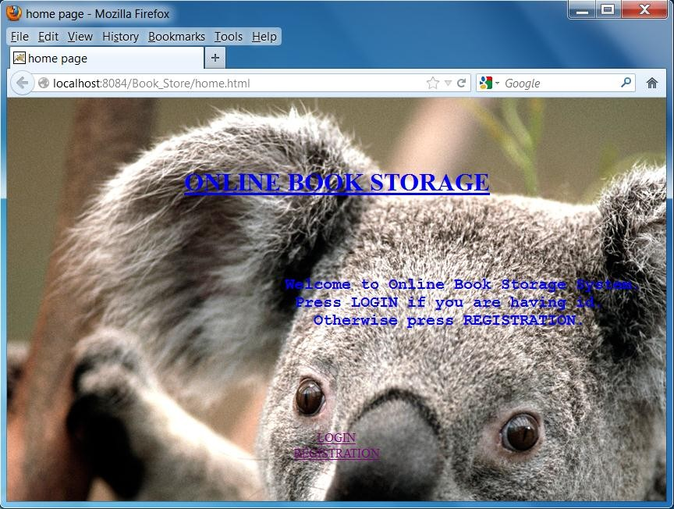

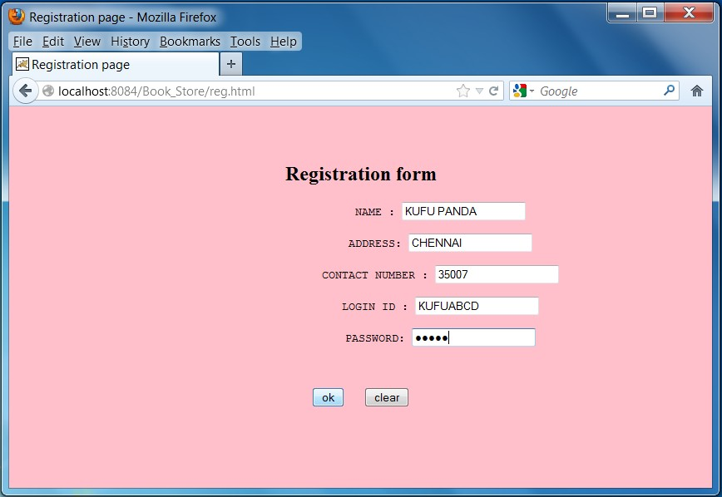

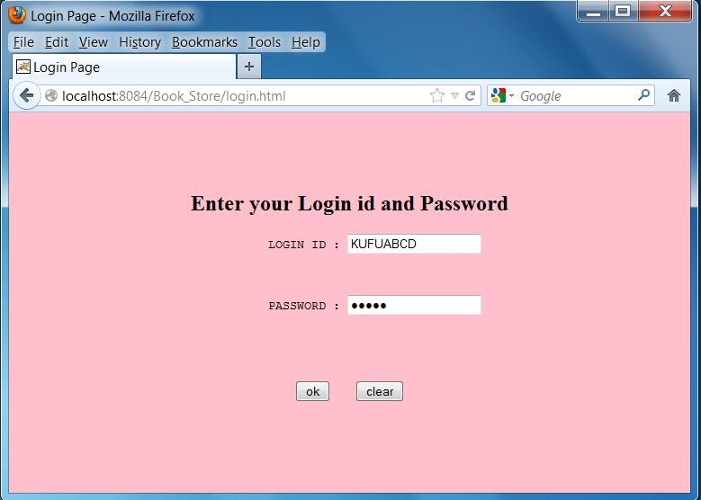

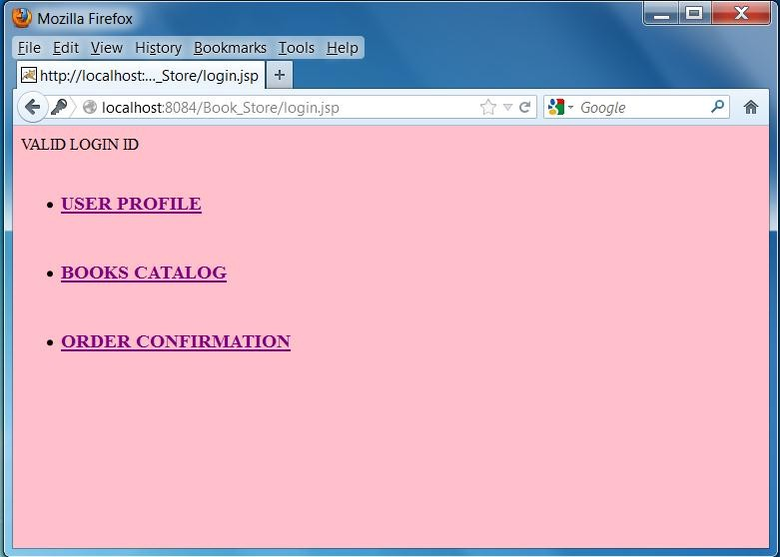

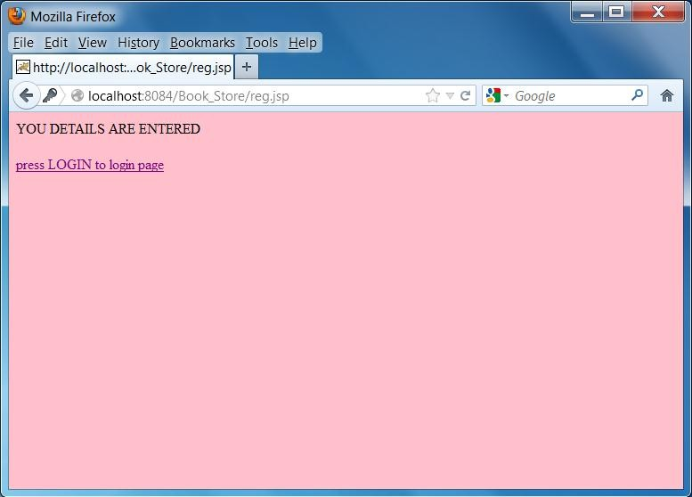

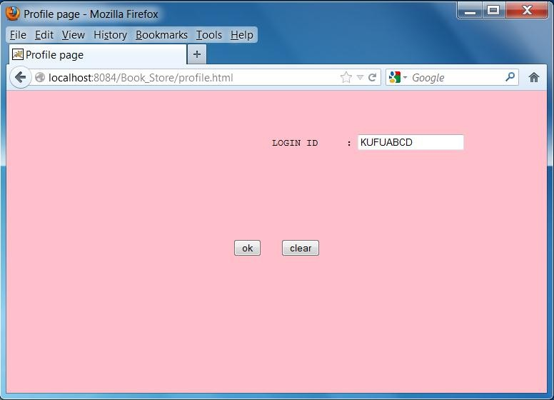

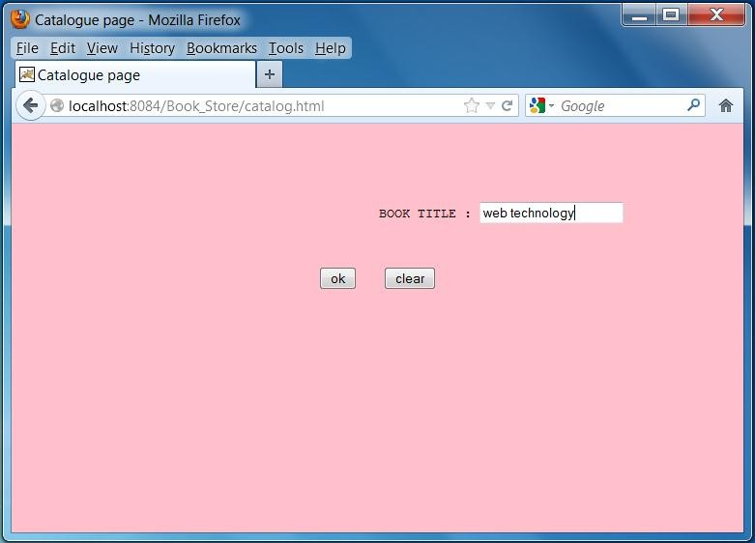

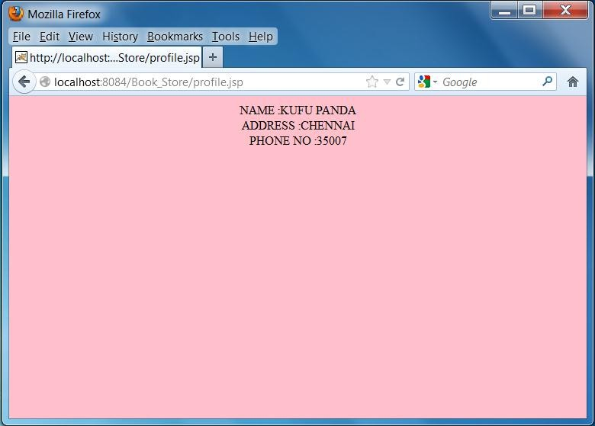

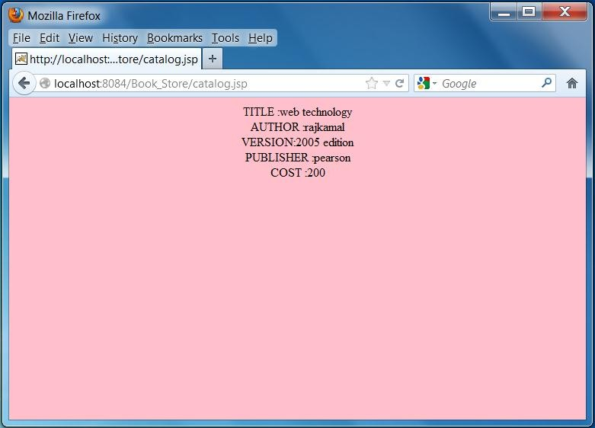

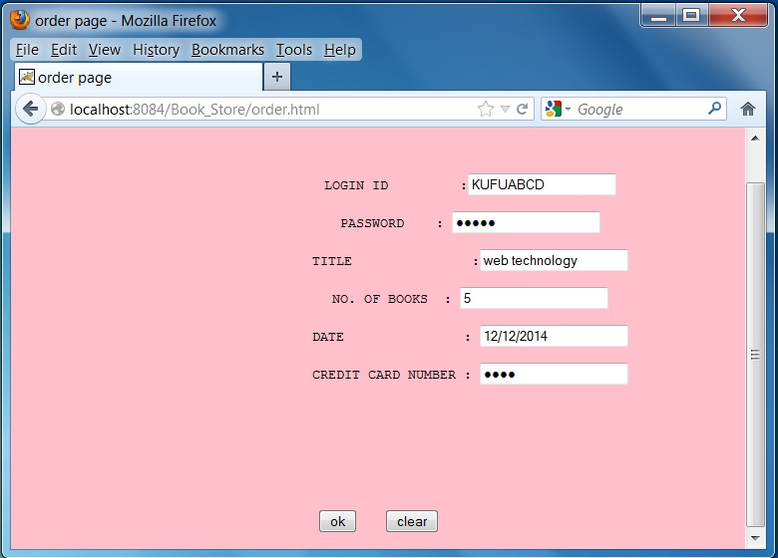

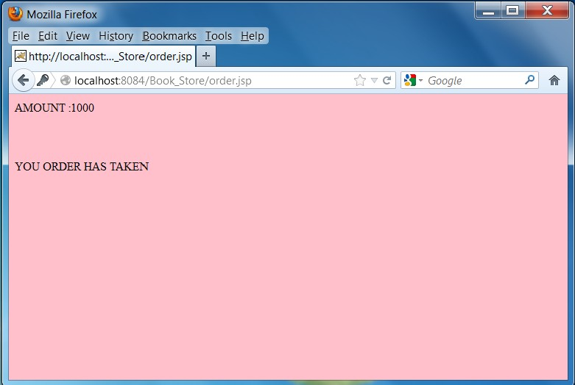

### Database table creation:

1. create table login(name varchar(20),addr varchar(20),phno number(20),id varchar(20),pwd varchar(20));
2. create table book(title varchar(20),author varchar(20),version varchar(20),publisher varchar(20),cost number(20));
3. insert into book values('web technology','rajkamal','2005 edition','pearson',200);
4. create table details(id varchar(20),title varchar(20),amount varchar(20),date1 varchar(20),cno varchar(20));

**RESULT:**

Thus the online book store web application has been developed and output verified.

**14.STUDENT DETAILS**

### AIM:

To develop a web application for student details using servlet.

### PROCEDURE:

Step 1: The main aim is to develop an application for student details. Step 2: To develop this, servlet codes are embedded in the java code. Step 3: Connect the database using Oracle

Step 4: Student details are stored in the database.

Step 5: The details are retrived from the database and displays in the web page. Step 6: Application works using Apache Tomcat Server.

### SOURCE PROGRAM:

**Home.html:**

<html>

<head>

<title>Home Page</title>

</head>

<body>

<form name="MyForm" action="student" method="post">

<table>

<tr>

<td> Enter Name :</td>

<td> <input type="text" name="txtname" size="30"> </td>

</tr>

</table>

<input type="submit" name="submit" value="Ok">

</form>

</body>

</html>

### Student.java:

import java.io.IOException; import java.io.PrintWriter;

import javax.servlet.ServletException; import javax.servlet.http.HttpServlet;

import javax.servlet.http.HttpServletRequest; import javax.servlet.http.HttpServletResponse; import java.sql.*;

public class student extends HttpServlet

{

protected void processRequest(HttpServletRequest request, HttpServletResponse response) throws ServletException, IOException {

response.setContentType("text/html;charset=UTF-8"); PrintWriter out = response.getWriter(); out.println("<html>");

out.println("<head>"); out.println("<title>Servlet NewServlet</title>"); out.println("</head>");

out.println("<body>"); out.println("<h3> Student</h3>"); try {

Class.forName("oracle.jdbc.driver.OracleDriver"); Connection connection =

DriverManager.getConnection("jdbc:oracle:thin:@localhost:1521:XE", "system", "raji"); String name = request.getParameter("txtname");

PreparedStatement ps = connection.prepareStatement("SELECT * FROM student WHERE name = ? ");

ps.setString(1, name);

ResultSet rs = ps.executeQuery(); while(rs.next())

{

out.print("RegNo : "+rs.getInt("rollno")+"<br>"); out.print("Name : "+rs.getString("name")+"<br>"); out.print("Dept : "+ rs.getString("department")+"<br>");

}

rs.close();

ps.close(); connection.close();

}

catch (Exception ex)

{

out.print(ex);

}

out.println("</body>"); out.println("</html>");

}

### Database table creation:

1. create table student(rollno number(20),name varchar(20),department varchar(20));
2. insert into student values(4006,'raji','cse');

### OUTPUT:

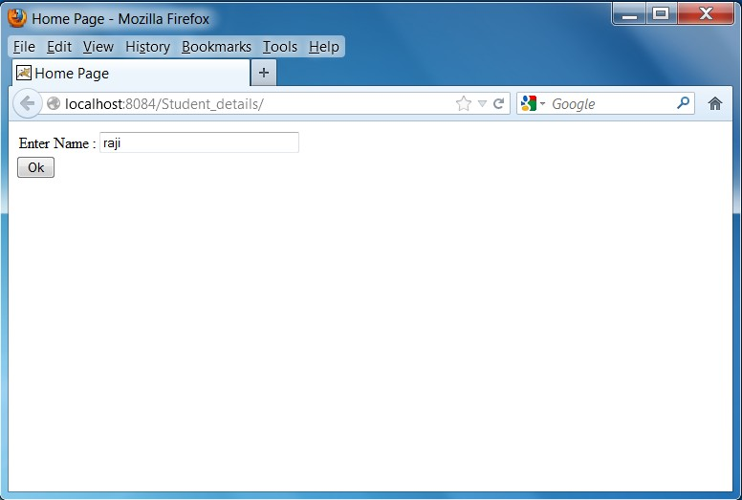

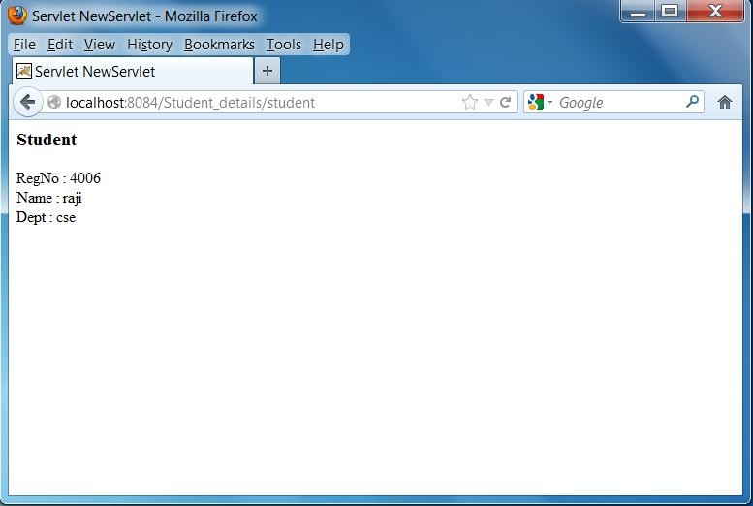

### RESULT:

Thus the student details web application has been developed and output verified.

### 15. STUDENT QUIZ

### AIM:

To develop a web application for sudent quiz using servlet.

### PROCEDURE:

Step 1: The main aim is to develop a Quiz application using servlet concepts. Step 2: To develop this, servlet codes are embedded in the java code.

Step 3: Connect the database using Oracle

Step 4: Questionnaries are stored in the database.

Step 5: The score is obtained after completing the quiz.

Step 6: Finally the application works using Apache Tomcat Server.

### SOURCE PROGRAM:

**Welcome.html**

<html>

<head>

<title>Welcome Page</title>

</head>

<body>

<h2>Welcome to Java QUIZ</h2>

<h3> <a href="Question"> Click here to Start</a></h3>

</body>

</html>

### Question.java:

import java.io.*;

import java.sql.Connection; import java.sql.DriverManager; import java.sql.ResultSet; import java.sql.Statement; import java.util.ArrayList; import javax.servlet.*;

import javax.servlet.http.*;

public class Question extends HttpServlet

{

protected void processRequest(HttpServletRequest request, HttpServletResponse response) throws ServletException, IOException {

response.setContentType("text/html;charset=UTF-8");

PrintWriter out = response.getWriter(); out.println("<html>"); out.println("<head>");

out.println("<title>Servlet NewServlet</title>"); out.println("</head>");

out.println("<body>"); out.println("<form action='Score'>"); out.println("<h1> Servlet QUIZ </h1>"); try

{

Class.forName("oracle.jdbc.driver.OracleDriver"); Connection connection =

DriverManager.getConnection("jdbc:oracle:thin:@localhost:1521:XE","system","raji"); Statement st=connection.createStatement();

ResultSet rs=st.executeQuery("Select * from QUIZ"); int count=0;

ArrayList<Integer> ans = new ArrayList<Integer>() ; while(rs.next()) {

out.print("Question "+rs.getInt("questionnumber")+" : "); out.print(rs.getString("question")+"<br>"); out.print("Ans 1 : "+rs.getString("choice1")+"<br>"); out.print("Ans 2 : "+ rs.getString("choice2")+"<br>"); out.print("Ans 3 : "+rs.getString("choice3")+"<br>"); out.print("Ans 4 : "+ rs.getString("choice4")+"<br>");

out.print("<input type=\"radio\" name=" + count + " value=\"1\">Ans 1<br>"); out.print("<input type=\"radio\" name=" + count + " value=\"2\">Ans 2<br>"); out.print("<input type=\"radio\" name=" + count + " value=\"3\">Ans 3<br>"); out.print("<input type=\"radio\" name=" + count + " value=\"4\">Ans 4<br>"); out.print("----------------------------------------------"+"<br><br>");

ans.add(rs.getInt("answernumber")); count++;

}

rs.close();

st.close(); connection.close();

HttpSession session = request.getSession(); session.setAttribute("answer", ans); out.print("<input type='submit' value='go'>");

}

catch (Exception ex)

{

out.print(ex);

}

out.println("</form>"); out.println("</body>"); out.println("</html>");

}

}

### Score.java:

import java.io.*;

import java.util.ArrayList; import javax.servlet.*; import javax.servlet.http.*;

public class Score extends HttpServlet

{

protected void processRequest(HttpServletRequest request, HttpServletResponse response) throws ServletException, IOException

{

response.setContentType("text/html;charset=UTF-8"); PrintWriter out = response.getWriter(); out.println("<h1>Servlet Score at </h1>");

try {

HttpSession session = request.getSession(true);

ArrayList<Integer> ans = (ArrayList<Integer>) session.getAttribute("answer"); int score=0;

for(int i=0;i<ans.size();i++)

{

int stuans = Integer.parseInt(request.getParameter(String.valueOf(i))); int answer = ans.get(i);

if(stuans == answer)

{

score++;

}

}

out.println("Score:");

out.println(score + " Out of " + ans.size());

}

finally

{

out.close();

}

}

}

### OUTPUT:

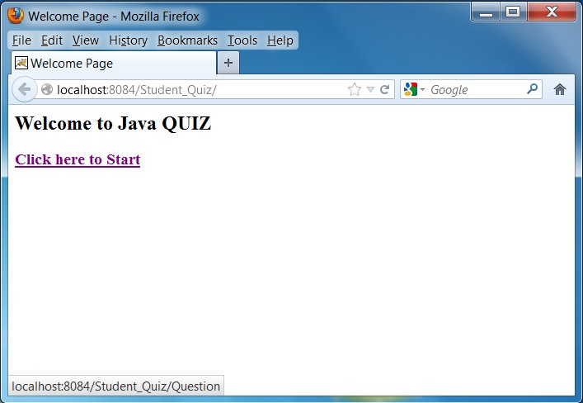

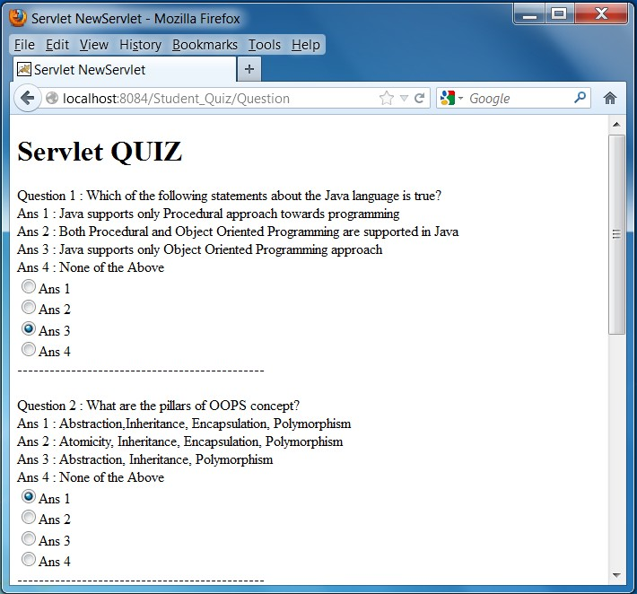

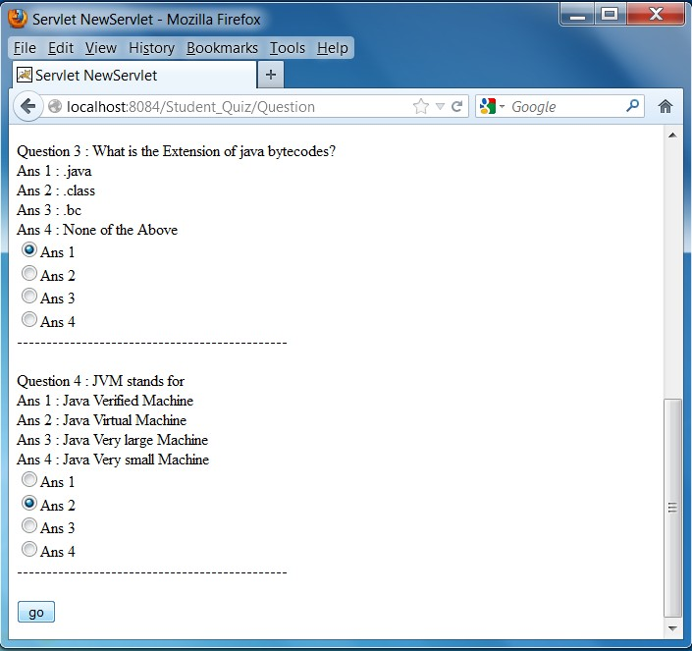

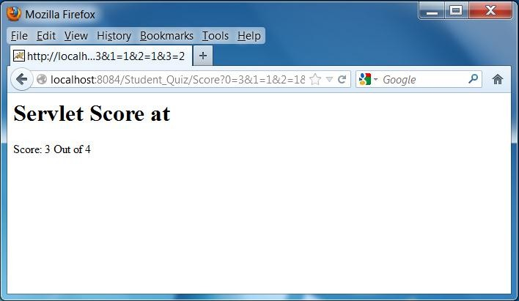

### Database table creation:

CREATE TABLE "QUIZ" ("QUESTIONNUMBER" NUMBER NOT NULL, "QUESTION" VARCHAR2(100), "CHOICE1" VARCHAR2(100),"CHOICE2" VARCHAR2(100),"CHOICE3" VARCHAR2(100),"CHOICE4" VARCHAR2(100),"ANSWERNUMBER" NUMBER);

INSERT INTO quiz VALUES (1,

'Which of the following statements about the Java language is true?', 'Java supports only Procedural approach towards programming',

'Both Procedural and Object Oriented Programming are supported in Java', 'Java supports only Object Oriented Programming approach',

'None of the Above', 3);

INSERT INTO quiz VALUES( 2,

'What are the pillars of OOPS concept?', 'Abstraction,Inheritance, Encapsulation, Polymorphism', 'Atomicity, Inheritance, Encapsulation, Polymorphism', 'Abstraction, Inheritance, Polymorphism',

'None of the Above', 1);

INSERT INTO quiz VALUES( 3,

'What is the Extension of java bytecodes?', '.java',

'.class',

'.bc',

'None of the Above', 2);

INSERT INTO quiz VALUES( 4,

'JVM stands for',

'Java Verified Machine', 'Java Virtual Machine', 'Java Very large Machine', 'Java Very small Machine', 2);

### RESULT:

Thus the student details web application has been developed and output verified.

**16. AIRLINE RESERVATION SYSTEM(MINI PROJECT)**

### AIM:

To develop a web application for Implementation of Airline Reservation System using Servlets.

### PROCEDURE:

Step 1: Start.

Step 2: Create Airline home page for login form and register the details of Passengers.

Step 3: Create a registration form for Reservation Details of Passengers like Date of travelling, to, From, Time of travelling etc…

Step 4: When the Passenger is entered their details and click Reserve button.

Step 5: Then the Passenger details are stored in oracle Database.

Step 6: Compile and execute the programs according to the settings given below.

Step 7: Stop.

### SOURCE PROGRAM:

**index.html**

<html>

<head>

<title> Airline Reservation - Home page </title>

</head>

<body>

<center>

<font size="8" color=red> WELCOME TO AIRLINE RESERVATION </font>

</center>

<form name="form1" action="register.jsp">For new Registration

<input name="joinnow" type="submit" value="&gt;&gt; New User">

</form> <br>

<form name="form2" method="post" action="login">

<table width="25%" border="1" align="center" cellpadding="1" cellspacing="1" style="border:#FC3 2px solid">

<tr>

</tr>

<tr>

</tr>

<td align="center" colspan=2> <font size=5> <b> LOGIN </b> </font> <br> </td>

<td width="60%" align="left"> <strong> User Name : </strong> </td>

<td align="right"> <input name="txtname" type="text"> </td>

<tr>

</tr>

<tr>

<td width="60%" align="left"> <strong> Password : </strong> </td>

<td align="right"> <input name="txtpwd" type="password"> </td>

<td colspan=2 align=center><input type=submit value="&nbsp&nbsp&nbsp GO &nbsp&nbsp&nbsp">

</tr>

</table>

</form>

</body>

</html>

**Register.jsp**

<html>

<head>

<title>

New User Registration

</title>

</head>

<body>

<form name="f1" action="register" method="Post">

<center>

<font size=6><b> NEW REGISTRATION </b>

</font>

<table>

<tr><td> Customer Name <td> :

<td><input type="text" name="name">

<tr><td> Password <td> :

<td><input type="password" name="pwd">

<tr><td> Address <td> :

<td><input type="text" name="addr">

</table>

<br><br>

<input type="submit" value="Register">

</center>

</form>

</body>

</html>

### ticketreserv.html:

<html>

<head>

<title> Reservation Form </title>

</head>

<body>

<h1> Airline Ticket Reservation </h1> <br> <br>

<form name="f1" action="ticketreserv" method="post"> Enter your Name: <input type="text" name="name"><br>

Enter mobile number: <input type="text" name="mob"><br> Select the Source:

<select name="source">

<option>Chennai</option>

<option>Mumbai</option>

<option>Delhi</option>

</select> <br>

Select the Destination:

<select name="destination">

<option>Chennai</option>

<option>Mumbai</option>

<option>Delhi</option>

</select> <br>

Select the number of seats:

<select name="seats">

<option>1</option>

<option>2</option>

<option>3</option>

</select> <br>

<input type="submit" name="submit" value="Book Ticket">

</form>

</body>

</html>

**list.html:**

<html>

<head>

<title> Link Form </title>

</head>

<body>

<a href="index.html"> <h1> Home </h1> </a>

<a href="ticketreserv.html"> <h1> Ticket Reservation </h1> </a>

<a href="seats.html"> <h1> Seats Availability </h1> </a>

<a href="ticketcanc.html"> <h1> Ticket Cancellation </h1> </a>

</body>

</html>

**seats.html:**

<html>

<head>

<title> Seat Availability Form </title>

</head>

<body>

<h1> Airline Seats Availability </h1> <br> <br>

<form name="f1" action="seatavai" method="post"> Select the Source:

<select name="source">

<option>Chennai</option>

<option>Mumbai</option>

<option>Delhi</option>

</select> <br>

Select the Destination:

<select name="destination">

<option>Chennai</option>

<option>Mumbai</option>

<option>Delhi</option>

</select><br>

<input type="submit" name="submit" value="Check Availability">

</form>

</body>

</html>

### ticketcanc.html:

<html>

<head>

<title> Cancellation Form </title>

</head>

<body>

<h1> Airline Ticket Cancellation </h1> <br> <br>

<form name="f1" action="ticketcanc" method="post"> Enter your Name: <input type="text" name="name"><br>

<input type="submit" name="submit" value="Cancel Tickets">

</form>

</body>

</html>

**Login.java:**

import java.sql.*;

public class login extends HttpServlet {

protected void doPost(HttpServletRequest request,HttpServletResponse response)throws ServletException,IOException {

response.setContentType("text/html"); PrintWriter out = response.getWriter();

try

{

Class.forName("oracle.jdbc.driver.OracleDriver");

Connection conn = DriverManager.getConnection ("jdbc:oracle:thin:@localhost:1521:XE", "system", "root");

PreparedStatement st = conn.prepareStatement("select * from customer where name =? AND password=?");

Strin uname=request.getParameter("txtname"); String pwd=request.getParameter("txtpwd"); st.setString(1,uname);

st.setString(2,pwd);

ResultSet rs = st.executeQuery();

boolean flag=false;

if(rs.next())

{

flag=false;

String name=rs.getString(1); String password=rs.getString(2);

if(uname.equals(name)&&pwd.equals(password))

{

flag=true;

}

}

if(flag)

{

out.println("<b><font size=12><center>RESERVATION FORM</font size=15></b>"); request.getRequestDispatcher("list.html").include(request,response);

}

else

request.getRequestDispatcher("index.html").include(request,response);

}

}

catch(Exception e)

{

out.println("Error :"+e);

}

}

### register.java:

import java.sql.*;

public class register extends HttpServlet

{

protected void doPost(HttpServletRequest request, HttpServletResponse response) throws ServletException, IOException

{

response.setContentType("text/html"); PrintWriter out = response.getWriter(); String VAL1=request.getParameter("name");

String VAL2=request.getParameter("pwd"); String VAL3=request.getParameter("addr"); try

{

Class.forName("oracle.jdbc.driver.OracleDriver"); Connection conn =

DriverManager.getConnection("jdbc:oracle:thin:@localhost:1521:XE","system","root"); PreparedStatement ps=null;

String query="insert into customer(name,password,address) values(?,?,?)";

ps=conn.prepareStatement(query);

ps.setString(1, VAL1); ps.setString(2, VAL2); ps.setString(3, VAL3); ps.executeUpdate(); out.println("<html>"); out.println("<body>");

out.println("\nName is: "+VAL1+"<br>"); out.println("Password is: "+VAL2+"<br>"); out.println("Address is : "+VAL3+"<br>"); out.println("<br>Details are Registered successfully"); out.println(" <p align=bottom><font size=12>"); out.println("<a href=index.html>------HOME--------</a>"); out.println("</body></html>");

}

catch(Exception e) {

System.out.println("Error :"+e);

}

}

**ticketreserv.java**

public class ticketreserv extends HttpServlet {

protected void doPost(HttpServletRequest request,HttpServletResponse response)throws

ServletException,IOException {

response.setContentType("text/html");

PrintWriter out = response.getWriter();

String name=request.getParameter("name");

int mob=Integer.parseInt(request.getParameter("mob"));

String source=request.getParameter("source");

String destination=request.getParameter("destination");

int seats=Integer.parseInt(request.getParameter("seats"));

PreparedStatement pt=null;

Connection conn=null; ResultSet rs=null;

try {

Class.forName("oracle.jdbc.driver.OracleDriver");

conn = DriverManager.getConnection("jdbc:oracle:thin:@localhost:1521:XE", "system", "root");

String q="insert into ticketreserv (name, mobno, source,destination,seats) values(?,?,?,?,?)";

pt=conn.prepareStatement(q);

pt.setString(1, name);

pt.setInt(2, mob);

pt.setString(3, source);

pt.setString(4, destination);

pt.setInt(5, seats);

pt.executeUpdate();

out.println("<html>");

out.println("<body>Tickets Reserved Successfully</body>");

out.println("<html>");

out.println("<a href=list.html>------HOME--------</a>");

}

catch(Exception e)

{

System.out.println("Error :"+e);

}

}

### seatavai.java:

public class seatavai extends HttpServlet {

protected void doPost(HttpServletRequest request,HttpServletResponse response)throws

ServletException,IOException

{

response.setContentType("text/html");

PrintWriter out = response.getWriter();

String source=request.getParameter("source");

String destination=request.getParameter("destination");

try

{

boolean flag=false; int count=0;

Class.forName("oracle.jdbc.driver.OracleDriver");

Connection conn = DriverManager.getConnection("jdbc:oracle:thin:@localhost:1521:XE", "system", "root");

PreparedStatement pt=conn.prepareStatement("select * from ticketreserv");

ResultSet rs=pt.executeQuery();

while(rs.next())

{

String source1=rs.getString(3);

String destination1=rs.getString(4);

int seats1=Integer.parseInt(rs.getString(5));

if(source.equals(source1)&&destination.equals(destination1))

{

count+=seats1;

}

}

out.println("<html>");

out.println("<body>");

if(count<50)

{

int seats=50-count;

out.println("<h3> Flight from:" +source+ "to" +destination+"</h3><br>");

out.println("Seats Available:" +seats);

}

else

{

out.println("No seats Available");

}

out.println("</body>");

out.println("<a href=list.html>------HOME--------</a>");

out.println("</html>");

}

catch(Exception e)

{

System.out.println("Error :"+e);

}

}

### ticketcanc.java:

public class ticketcanc extends HttpServlet {

protected void doPost(HttpServletRequest request, HttpServletResponse response) throws

ServletException, IOException {

response.setContentType("text/html");

PrintWriter out = response.getWriter();

String name=request.getParameter("name");

try {

boolean flag=false;

Connection conn = DriverManager.getConnection("jdbc:oracle:thin:@localhost:1521:XE", "system", "root");

PreparedStatement pt=conn.prepareStatement("select name from ticketreserv where name=?"); pt.setString(1,name);

ResultSet rs=pt.executeQuery();

while(rs.next())

{

String name1=rs.getString(1); if(name.equals(name1))

{

pt = conn.prepareStatement("DELETE FROM ticketreserv WHERE name= '" + name1 + "'"); pt.executeQuery();

flag=true; out.println("<html>");

out.println("<body><h1>Ticket Cancellation</h1>"); out.println("<br><br>");

out.println("Tickets Cancelled");

}

}

if(flag==false)

{

out.println("User does not exist");

}

out.println("</body>");

out.println("</html>");

}

catch(Exception e)

{

System.out.println("Error :"+e);

}

}

### OUTPUT

**Home page:**

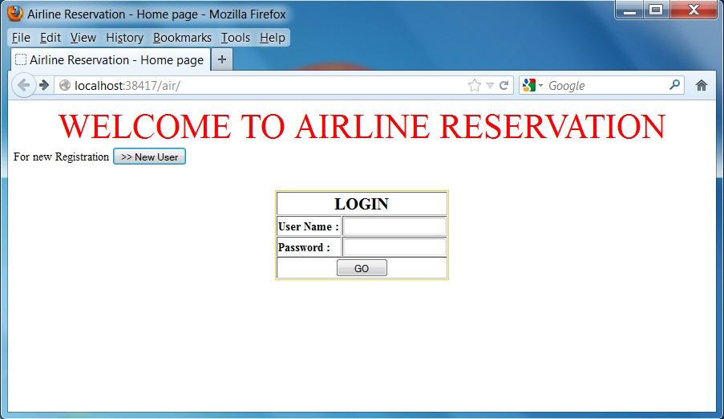

**New user registration form:**

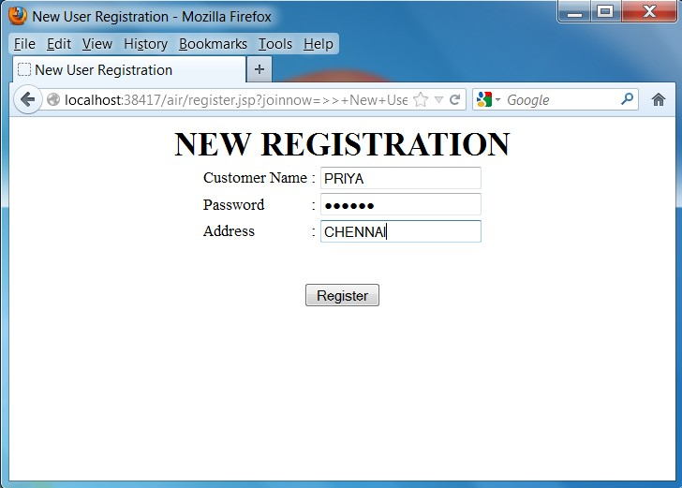

# Registration Successfully:

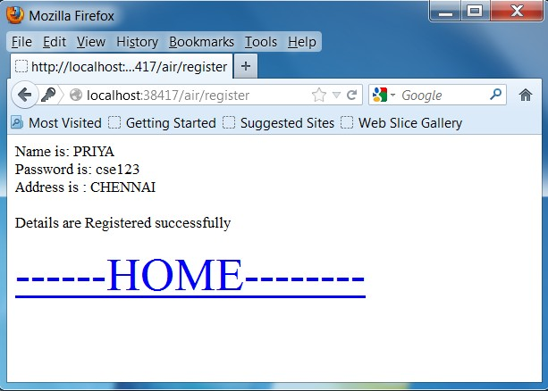

**Login Form:**

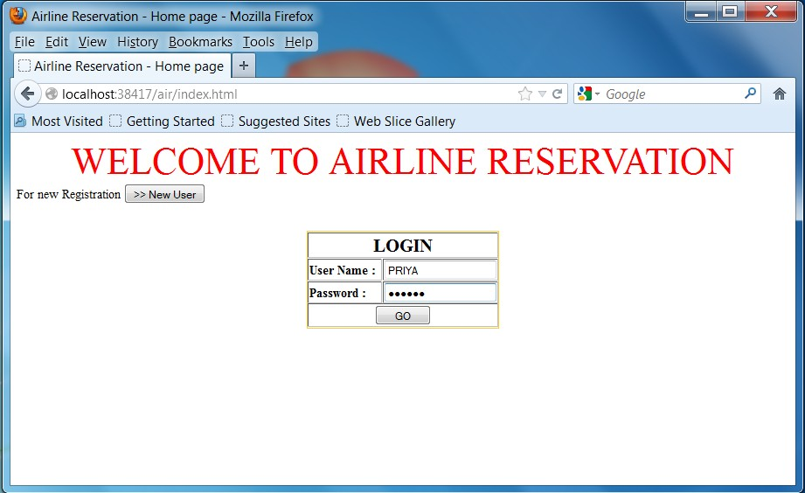

# Link Form:

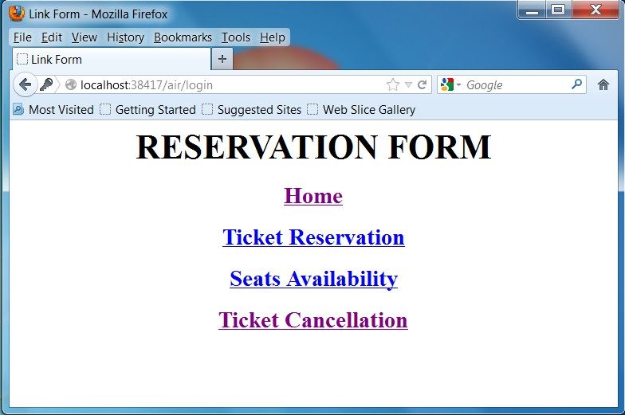

**Ticket Reservation Form:**

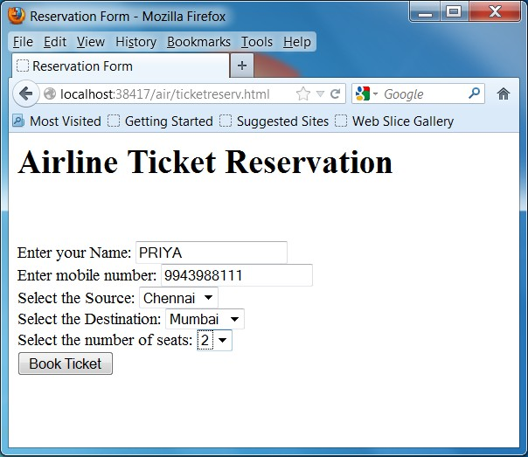

# Ticket Booked Successfully:

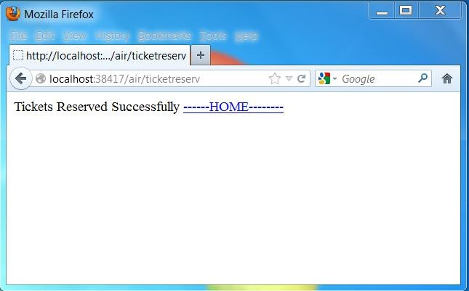



# Seat Availability Form:

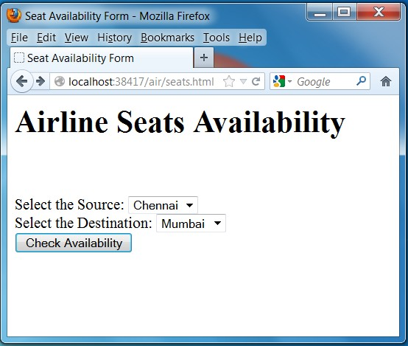

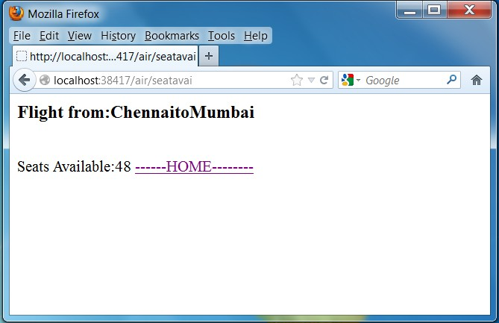

# Ticket Cancellation:



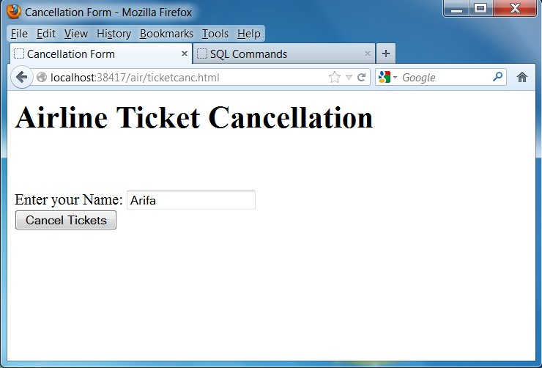

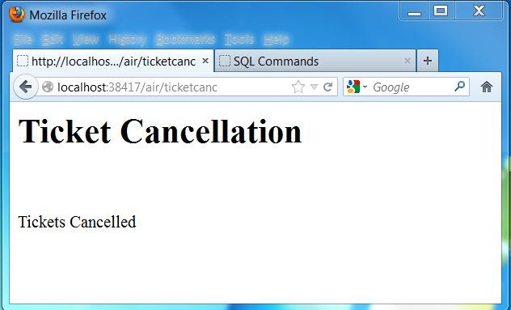

# DATABASE:

## create table customer(name varchar2(20) primary key, password varchar2(20),address varchar(20));

create table ticketreserv(name varchar2(20) primary key, mobno number(20),source varchar2(20),destination varchar2(20),seats number(20));

select * from customer;

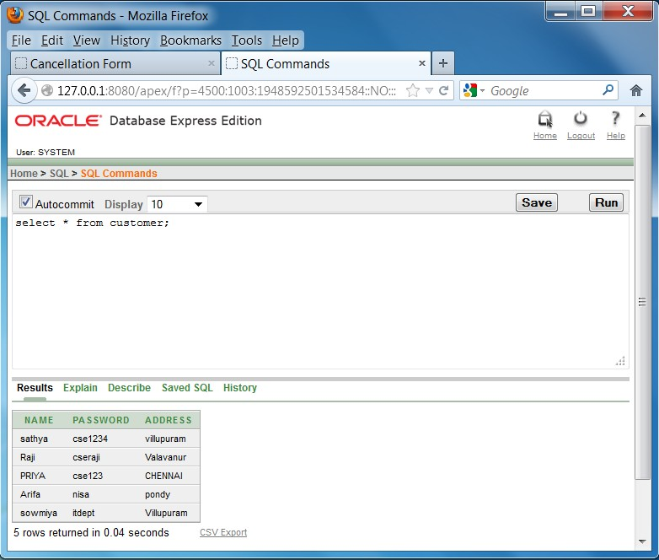

## select * from ticketreserv;

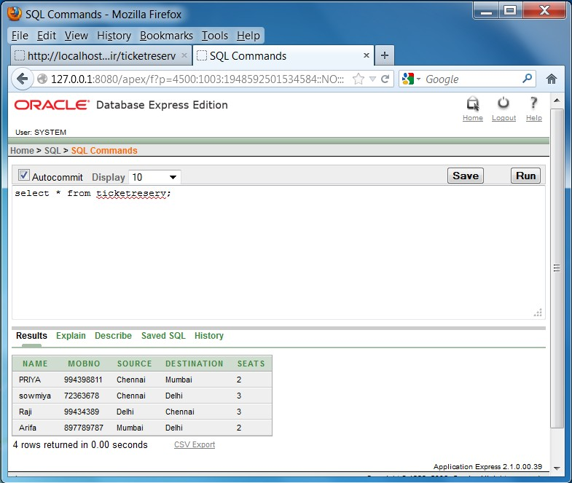

### RESULT:

Thus the Airline Reservation System using Servlet web application is created and output verified.