

**SECTION-A(20 Marks)-Part-1(10*2=20 Marks)**

**ANSWER ALL THE QUESTIONS**

**1.Mobile Computing:**

Mobile Computing refers a technology that allows transmission of data, voice and video via a computer or any other wireless enabled device. It is free from having a connection with a fixed physical link

**2.Spread spectrum modulation scheme:**

The spread spectrum is a type of modulation where modulated signal BW is much larger than the baseband signal BW i.e. spread spectrum is a **wide band scheme**.

**3.GSM:**

**GSM** stands for **Global System for Mobile Communication**.  
It is a standard developed by the **European Telecommunication Standards Institute(ETSI)** to describe protocols for 2G networks.

**4.MSS:**

These stationary hosts are called **mobile support stations** (MSS) or base stations which perform the transaction and data management functions with the help of transaction managers (TMs) and data managers (DMs), respectively.

**5.Major categories of wireless technology:**

Major categories of wireless technology in mobile computing include cellular networks (e.g., 4G LTE, 5G) for wide area coverage and Wi-Fi for local area connectivity, offering diverse options for data transmission and internet access on-the-go.

**6.UMTS:**

**UMTS** or **Universal Mobile Telecommunications Framework**, is the 3G successor to the GSM family of measures counting GPRS and EDGE.

**7.ACTS:**

ACTS (Advanced Communication Technology Satellite) in mobile computing provides satellite-based communication services, offering wide-area coverage for remote regions and supporting applications such as voice, data, and internet access in areas with limited terrestrial infrastructure.

**8.Pilot channel:**

In mobile computing, the pilot channel is a control channel used in CDMA (Code Division Multiple Access) systems to transmit synchronization, timing, and power control information between the mobile device

**9.Soft hand-off:**

Soft handoff in mobile computing refers to a seamless transition where a mobile device simultaneously connects to multiple base stations during a handover, ensuring uninterrupted communication and enhanced reliability in cellular networks such as CDMA.

**10.University Unique Identifiers:**

University Unique Identifiers (UUIDs) in mobile computing may refer to identifiers assigned to universities or educational institutions within mobile applications or databases, enabling unique identification

**SECTION –B (55 MARKS)**

**PART=II(5*11=55)**

**ANSWER THE QUESTIONS**

**11.Digital cellular system:**

Early wireless systems had a high-power transmitter, covering the entire service area. This required a very huge amount of power and was not suitable for many practical reasons.

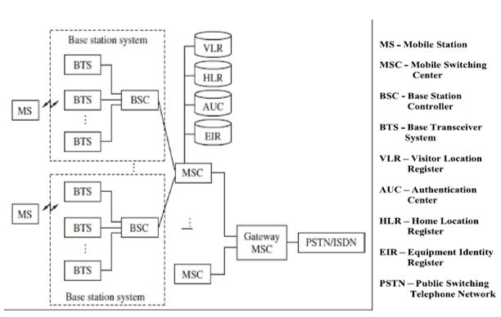

The HLR is located at the MSC where MS is initially registered and is the initial home location for billing and access information.

In simple words, any incoming call, based on the calling number, is directed to the HLR of the home MS where the MS is registered. The HLR then points to the VLR of the MSC where the MS is currently located.

Bidirectional HLR-VLR pointers help in carrying out various functionalities, as illustrated in the figure:

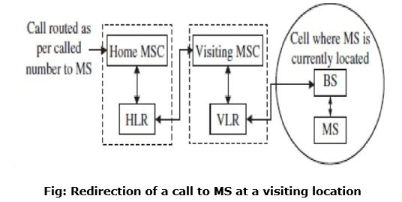

**OR**

**12.Palm-top computers and handheld computers:**

Palm-top computers and handheld computers are two distinct categories within mobile computing, each with its own characteristics and evolution:

1. **Palm-top Computers :**
   * Palm-top computers are compact, portable devices designed for personal organization and productivity tasks.
   * They typically feature a small form factor, often fitting in the palm of one's hand, hence the name "palm-top."
   * Input is commonly done using a stylus or touch-sensitive screen, with basic on-screen keyboards for text entry.
   * Palm-top computers usually include built-in applications for managing contacts, calendars, to-do lists, and notes.
   * They were particularly popular in the 1990s and early 2000s, with iconic devices like the PalmPilot leading the market.
2. **Handheld Computers :**
   * Handheld computers encompass a broader category of portable computing devices, including PDAs (Personal Digital Assistants) and smartphones.
   * These devices offer more advanced capabilities compared to palm-top computers, such as internet browsing, multimedia playback, and communication features.
   * Handheld computers typically have larger screens compared to palm-tops and may support various input methods, including physical keyboards, touchscreens, and styluses.
   * Smartphones, a subset of handheld computers, have become ubiquitous in modern society, offering a wide range of applications and functionalities beyond traditional computing tasks.
   * The evolution of handheld computers has been marked by advancements in technology, including faster processors, improved displays, and enhanced connectivity options.

In conclusion, while palm-top computers focus on basic personal organization and productivity, handheld computers offer a broader range of features and functionalities, with smartphones being the most prominent example in today's mobile computing landscape.

**13.TDMA,CDMA:**

**. Time Division Multiple Access (TDMA) :**  
TDMA is the channelization protocol in which bandwidth of channel is divided into various stations on a time basis. There is a time slot given to each station, the station can transmit data during that time slot only which is as follows:

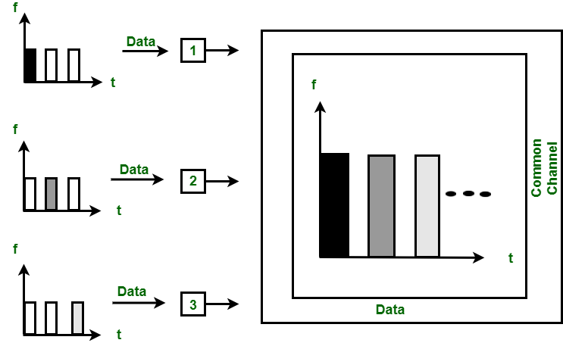

Each station must aware of its beginning of time slot and the location of the time slot. TDMA requires synchronization between different stations. It is type of access method in the data link layer. At each station, data link layer tells the station to use the allocated time slot.

**Code Division Multiple Access (CDMA) :**  
In CDMA, all the stations can transmit data simultaneously. It allows each station to transmit data over the entire frequency all the time. Multiple simultaneous transmissions are separated by unique code sequence. Each user is assigned with a unique code sequence.

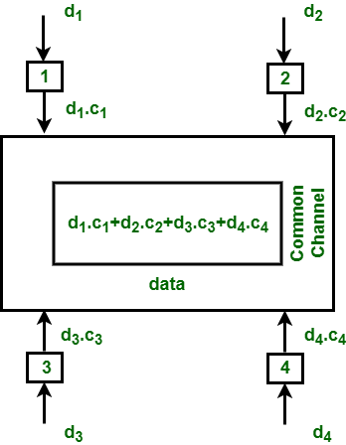

In the above figure, there are 4 stations marked as 1, 2, 3 and 4. Data assigned with respective stations as d1, d2, d3 and d4 and the code assigned with respective stations as c1, c2, c3 and c4.

**OR**

**14.  Basics of Digital Cellular Systems:**

Digital cellular systems are telecommunications systems that use digital technology to provide wireless voice and data services. Here are the basics of digital cellular systems:

1. **Frequency Reuse**: Digital cellular systems divide a geographic area into smaller cells, each served by a base station. Frequencies are reused across cells to maximize spectrum utilization while minimizing interference.
2. **Multiple Access Techniques**: Digital cellular systems employ multiple access techniques to allow multiple users to share the same radio resources. Common techniques include FDMA (Frequency Division Multiple Access), TDMA (Time Division Multiple Access), and CDMA (Code Division Multiple Access).
3. **Digital Modulation**: Instead of analog modulation used in older analog cellular systems, digital cellular systems utilize digital modulation techniques such as QPSK (Quadrature Phase Shift Keying) or QAM (Quadrature Amplitude Modulation) to encode voice and data signals.
4. **Channelization**: The available frequency spectrum is divided into multiple channels, each capable of carrying one voice call or data session. Each channel is typically divided into time slots or coded sequences for TDMA and CDMA systems, respectively.
5. **Handover and Roaming**: Digital cellular systems support seamless handover between cells as mobile users move within the network coverage area. Roaming allows users to access services when traveling outside their home network's coverage area, using agreements with other operators.
6. **Advanced Services**: Digital cellular systems support various advanced services beyond basic voice calls, including SMS (Short Message Service), MMS (Multimedia Messaging Service), internet access, and multimedia streaming.
7. **Security**: Digital cellular systems incorporate encryption and authentication mechanisms to secure communications between mobile devices and the network, protecting against eavesdropping and unauthorized access.
8. **Standards**: Digital cellular systems are based on standardized protocols and technologies developed by organizations such as the GSM Association (for GSM and its evolutions), 3rd Generation Partnership Project (3GPP), and International Telecommunication Union (ITU).

**15**. **various wireless network techniques:**

Various wireless network techniques encompass a range of technologies and methodologies for establishing and maintaining communication over wireless networks. Some of the prominent techniques include:

1. **Frequency Division Multiple Access (FDMA)**: Divides the frequency spectrum into multiple channels, each allocated to individual users or connections.
2. **Time Division Multiple Access (TDMA)**: Divides the transmission channel into time slots, allowing multiple users to share the same frequency channel by transmitting in different time intervals.
3. **Code Division Multiple Access (CDMA)**: Allows multiple users to transmit simultaneously over the same frequency band using unique codes to differentiate between signals.
4. **Orthogonal Frequency Division Multiplexing (OFDM)**: Divides the available spectrum into multiple subcarriers, allowing parallel transmission of data streams to increase throughput and improve resistance to multipath interference.
5. **Multiple Input Multiple Output (MIMO)**: Utilizes multiple antennas at both the transmitter and receiver to improve data throughput, reliability, and spatial diversity by exploiting multipath propagation.
6. **Software-Defined Networking (SDN)**: Separates the control plane from the data plane, enabling centralized management and dynamic configuration of wireless network resources.
7. **Mesh Networking**: Establishes decentralized networks where each node can communicate directly with neighboring nodes, providing redundancy, scalability, and self-healing capabilities.
8. **Beamforming**: Focuses radio signals in specific directions to increase signal strength and improve coverage, enhancing the efficiency of wireless communication.

**OR**

**16.**  **Third Generatiori Wireless Networks:**

Third-generation (3G) wireless networks in mobile computing represent a significant advancement over earlier generations, offering enhanced data rates, multimedia support, and a variety of advanced services. Here are key aspects of 3G networks in mobile computing:

1. **Higher Data Rates**: 3G networks provide significantly higher data rates compared to 2G networks, enabling faster internet browsing, multimedia streaming, and data-intensive applications.
2. **Multimedia Support**: 3G networks support multimedia services such as video calling, video conferencing, and high-quality audio streaming, enhancing the user experience with rich content.
3. **Wide Area Coverage**: 3G networks offer broader coverage areas, allowing users to access services and stay connected over larger geographical regions, including rural and remote areas.
4. **Advanced Technologies**: 3G networks employ advanced technologies such as WCDMA (Wideband Code Division Multiple Access) and CDMA2000 (Code Division Multiple Access 2000) to achieve higher data rates and improved spectral efficiency.
5. **Global Standards**: 3G networks are based on global standards such as UMTS (Universal Mobile Telecommunications System) and CDMA2000, ensuring interoperability and compatibility across different networks and regions.
6. **Data Services**: 3G networks enable a wide range of data services beyond traditional voice calls, including mobile internet access, email, social media, and location-based services, expanding the capabilities of mobile computing devices.
7. **Quality of Service (QoS)**: 3G networks support Quality of Service mechanisms to prioritize traffic and ensure a consistent user experience for time-sensitive applications such as voice and video calls.
8. **Evolution to 4G**: While 3G networks represented a significant advancement, they eventually paved the way for the deployment of fourth-generation (4G) networks, such as LTE (Long-Term Evolution), which offer even higher data rates, lower latency, and improved spectral efficiency.

**17. End User Applications:**

1. **Social Media**: Applications like Facebook, Instagram, Twitter, and Snapchat allow users to connect, share updates, photos, and videos with friends and followers.
2. **Messaging and Communication**: Messaging apps such as WhatsApp, Messenger, and Telegram facilitate text messaging, voice calls, video calls, and group chats over mobile networks or Wi-Fi.
3. **Email**: Email clients like Gmail, Outlook, and Apple Mail provide access to email accounts, allowing users to send, receive, and manage emails on the go.
4. **Web Browsers**: Mobile web browsers such as Chrome, Safari, and Firefox enable users to browse the internet, search for information, and access web-based services and content.
5. **Entertainment**: Mobile entertainment apps include streaming services like Netflix, YouTube, Spotify, and Apple Music for watching movies, TV shows, listening to music, and podcasts.
6. **Gaming**: Mobile gaming apps range from casual games like Candy Crush and Temple Run to more immersive and graphics-intensive titles like PUBG Mobile, Fortnite, and Clash of Clans.
7. **Navigation and Maps**: GPS-based navigation apps such as Google Maps, Apple Maps, and Waze provide turn-by-turn directions, real-time traffic updates, and location-based services like local business search.
8. **Productivity Tools**: Productivity apps like Microsoft Office, Google Workspace, and Evernote offer tools for creating, editing, and sharing documents, spreadsheets, presentations, and notes on mobile devices.
9. **E-commerce**: Shopping apps like Amazon, eBay, and Alibaba enable users to browse, shop, and make purchases online, with features such as product search, reviews, and secure payment options.
10. **Health and Fitness**: Health and fitness apps like Fitbit, MyFitnessPal, and Strava help users track their physical activity, set fitness goals, monitor health metrics, and connect with others for motivation and support.

**OR**

**18.**  **Unicast and Multicast discovery:**

1. **Unicast Discovery**:
   * **Definition**: Unicast discovery involves sending individual discovery messages to each potential target device or service in the network.
   * **Operation**: When a device needs to discover other devices or services, it sends out unicast discovery requests to specific IP addresses or network identifiers.
   * **Advantages**: Unicast discovery allows for precise targeting of discovery requests to specific devices or services, which can be useful in scenarios where only certain devices or services need to be discovered.
   * **Disadvantages**: This approach can be less efficient in terms of network overhead and latency, especially in environments with a large number of devices or services.
2. **Multicast Discovery**:
   * **Definition**: Multicast discovery involves broadcasting a single discovery message to multiple potential target devices or services in the network.
   * **Operation**: When a device needs to discover other devices or services, it sends out a multicast discovery message to a multicast group address shared by all devices interested in discovery.
   * **Advantages**: Multicast discovery reduces network overhead by sending a single message to reach multiple recipients simultaneously, which can improve efficiency and reduce latency, especially in scenarios with many devices or services.
   * **Disadvantages**: Not all networks or network devices support multicast communication, so compatibility issues may arise in some environments.

**19.  Mobility Middleware:**

1. **Location Management**: Mobility middleware often includes modules for location management, enabling applications to determine the current location of mobile devices using GPS, Wi-Fi, cellular positioning, or other location-aware technologies.
2. **Context Awareness**: Mobility middleware can provide context awareness capabilities, allowing applications to adapt their behavior based on factors such as the user's location, movement patterns, environmental conditions, and device status.
3. **Network Management**: Mobility middleware may offer network management functionalities to handle issues such as network handovers, connectivity disruptions, and switching between different types of networks (e.g., Wi-Fi, cellular) seamlessly.
4. **Resource Discovery**: Middleware components can facilitate the discovery of nearby resources, services, or devices in the mobile environment, enabling applications to locate and interact with other entities dynamically.
5. **Communication Support**: Mobility middleware often includes communication support for facilitating data exchange, messaging, and collaboration among mobile devices, enabling peer-to-peer communication or interaction with backend servers and services.
6. **Context Sharing and Synchronization**: Middleware solutions may provide mechanisms for sharing and synchronizing context information among multiple devices or applications, enabling collaborative or distributed computing scenarios.
7. **Security and Privacy**: Mobility middleware may incorporate security mechanisms such as authentication, encryption, access control, and privacy-preserving techniques to protect sensitive data and ensure secure communication in mobile environments.
8. **Device Adaptation**: Middleware frameworks can offer device adaptation features to abstract away differences in hardware capabilities, operating systems, and software platforms, enabling developers to create applications that run consistently across diverse mobile devices.
9. **Energy Efficiency**: Some mobility middleware solutions focus on energy efficiency, providing techniques for optimizing power consumption, managing battery usage, and prolonging the battery life of mobile devices.
10. **Application Development Support**: Mobility middleware may include development tools, APIs, and libraries to simplify the creation of mobile applications with mobility-related functionalities, reducing development time and effort for developers.

**OR**

**20.** **The need for mobile agents and  the components of mobile agent architecture:**

In Mobile Computing, Mobile Agents are the composition of computer software and data that can autonomously move from one computer to another computer and continue its execution on the destination computer.

Life Cycle of Mobile Agents:

The life cycle of mobile agents ensures the following conditions:

* They can adapt to the environment. For example, either home or foreign environment.
* They are capable of switching among the positions of one node to another.
* They are autonomous and focused on the final output.

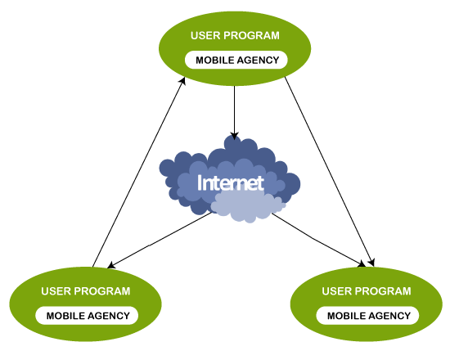

1. **Mobile Agents**: These are autonomous software entities that can move between different hosts in a network, carrying out tasks on behalf of their creators. Mobile agents encapsulate both code and data, allowing them to execute tasks locally on remote hosts.
2. **Agent Management System (AMS)**: The AMS is responsible for managing the lifecycle of mobile agents. It handles tasks such as agent creation, migration, scheduling, and termination. The AMS may also provide facilities for agent security, authentication, and communication.
3. **Agent Execution Environment**: This component provides the runtime environment in which mobile agents execute their tasks. It includes the necessary libraries, runtime support, and resources (such as memory and CPU) for agent execution. The execution environment ensures that agents can operate efficiently and securely on remote hosts.
4. **Communication Infrastructure**: Mobile agents require a communication infrastructure to facilitate their movement between hosts and interaction with other agents or services. This infrastructure typically includes protocols, middleware, and network services for agent communication, messaging, and coordination.
5. **Agent Platforms**: Agent platforms are software frameworks or environments that provide the infrastructure and tools for developing, deploying, and managing mobile agents. These platforms often include libraries, APIs, and development tools for agent programming, as well as runtime support for agent execution.
6. **Security Infrastructure**: Security is a critical concern in mobile agent systems. This component provides mechanisms for ensuring the integrity, confidentiality, and authenticity of mobile agents and their communications. It includes features such as encryption, digital signatures, access control, and secure communication protocols.
7. **Agent Repositories**: Agent repositories are centralized or distributed storage systems where mobile agents can be stored, retrieved, and accessed by agents or agent management systems. Repositories may also provide versioning, indexing, and searching capabilities for managing large numbers of agents.
8. **Monitoring and Logging**: Mobile agent systems often include components for monitoring agent activities, tracking their movements, and logging relevant events and interactions. Monitoring and logging tools provide visibility into agent behavior, performance, and security incidents.
9. **Integration with Applications**: Mobile agent architectures may need to integrate with existing applications, services, or systems in the network environment. This integration involves providing APIs, adapters, or interfaces for interacting with external components and exchanging data with other software entities.
10. **Policy Management**: Policy management components define rules, policies, and constraints that govern the behavior of mobile agents and their interactions with hosts, networks, and other agents